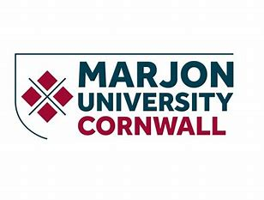

POST GRADUATE CERTIFICATE IN COACHING AND MENTORING

Pre-enrolment course reading

Garvey, B, Stokes, P. & Megginson, D. (2021). Coaching and Mentoring: Theory and Practice
(4th edition). Sage

Starr J. (2021). The Mentoring Manual: Your step by step guide to being a better mentor. (2nd edition). Pearson Education Ltd.
Starr, J. (2021). The Coaching Manual, (5th edition). Pearson Education Ltd

Van Nieuwerburgh, C. (2020). An Introduction to Coaching Skills, A Practical Guide (3rd edition). Sage.
Whitmore, J. (2017). Coaching for Performance: Growing human potential and purpose – the principles and practice of coaching and leadership (5th ed). Nicholas Brealey.

1

