BA (Hons) Criminology
Part-Time Indicative Timetable

Welcome Week – Week Beginning 19 September 2022
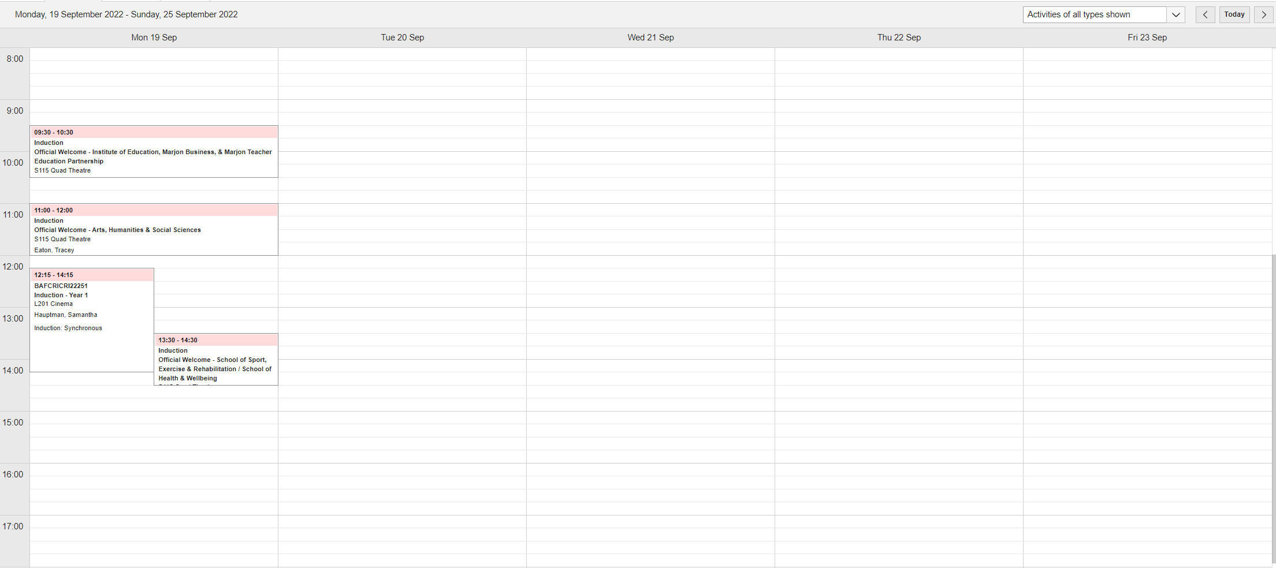

Week Beginning 26 September 2022

Week Beginning 3 October 2022
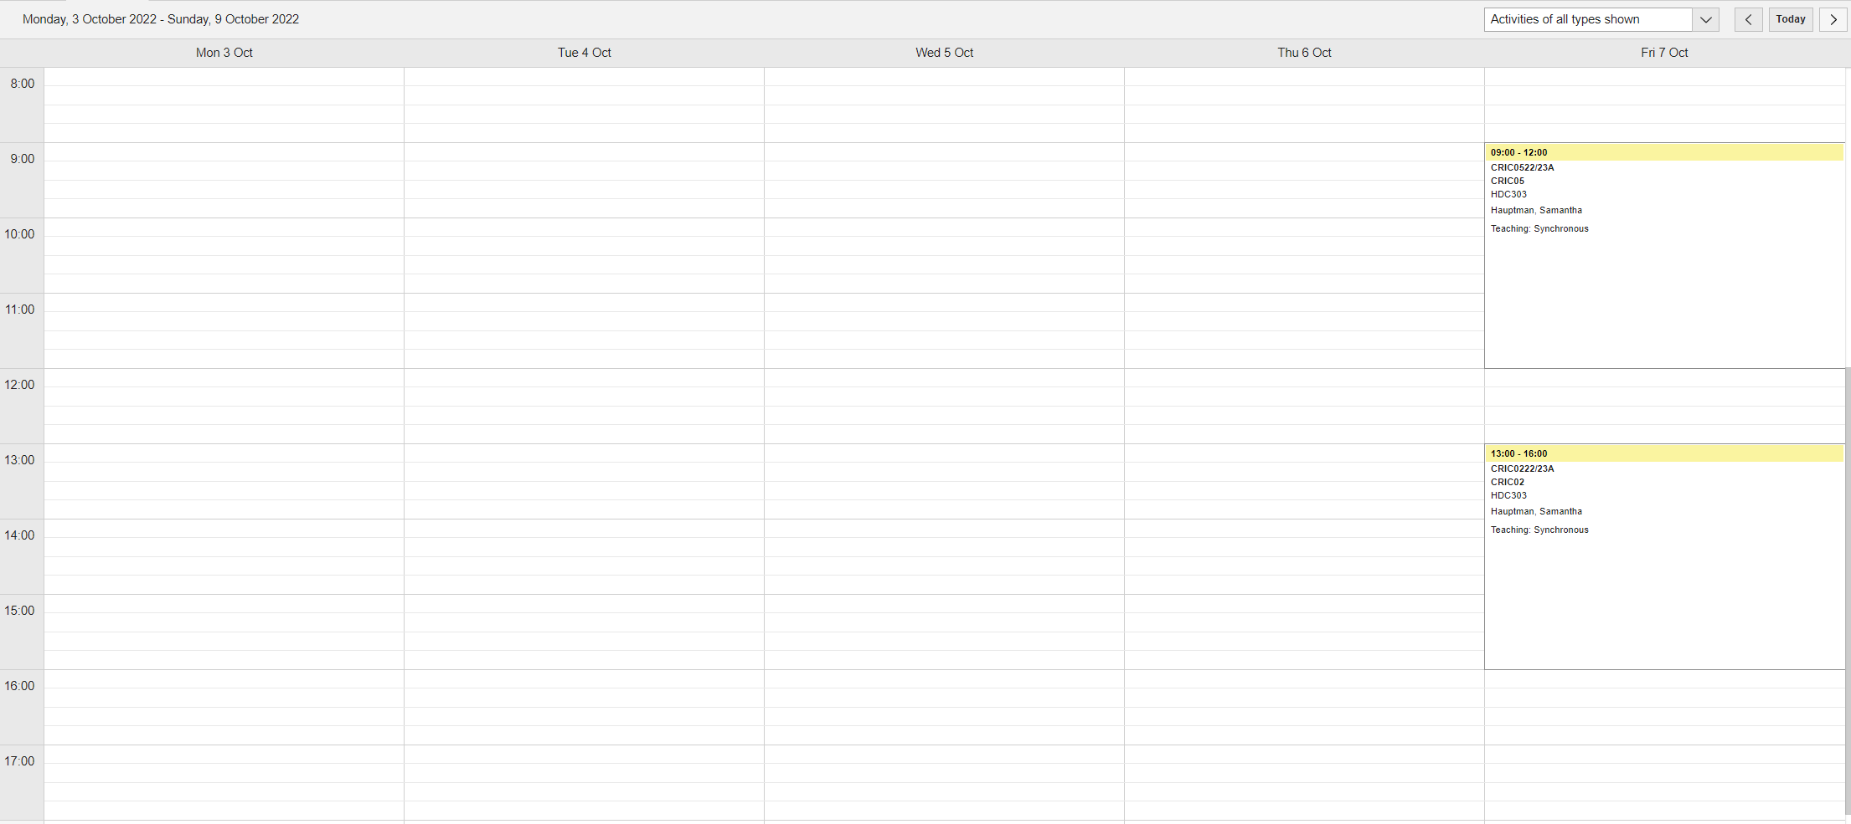

Week Beginning 10 October 2022

Week Beginning 17 October 2022
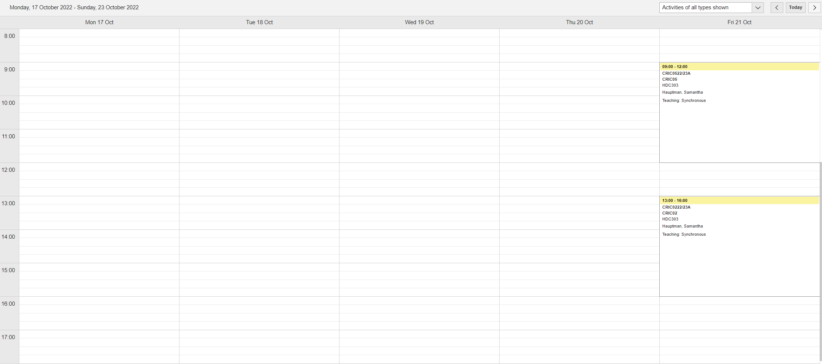

Week Beginning 24 October 2022

This is Reading Week – no teaching

