Welcome Week Induction Overview (September 2023)
1st Year Football Coaching and Development, Sport Development and Coaching, Sport Business Management
When | What | Where
Monday 18 Sept |  | Confirm room locations
11.00-12.00 | Sport, Coaching and PE Cluster Welcome  Welcome to the wider school cluster (shared with BA Football Coaching and Development, FD/BA Sport Development and Coaching and BSc Sport Business Management, BA Coaching and PE and BA PE students). | L201 Cinema (Lecture Theatre)
Tuesday 19 Sept
13.00-14.00 | Programme Leader / Team session  1st Programme Cluster Specific Welcome / Induction.  BA Football Coaching and Development, FD/BA Sport Development and Coaching and BSc Sport Business Management | E207
Wednesday 20 Sept
11.00-12.00 | Programme Leader / Team session  Second Programme Induction session  BA Football Coaching and Development, FD/BA Sport Development and Coaching and BSc Sport Business Management | L201 Cinema (Lecture Theatre)
13.00-14.00 | Programme Leader / Team session  All 1st years Personal Tutor Session | HDC101
Thursday 21 Sept
9.30-10.30: | ALL Year 1 (New Undergrads)  School of Sport, Exercise & Rehabilitation  Official Welcome (Quad Theatre) from the Dean, DoS, PLs  IN PERSON  IT in attendance in Arts café for troubleshooting IT connection issues. | Quad Theatre
13.00-15.00 | Practical Activities (wear sports kit) fun social activity. | Sports Hall 3
Friday 22 Sept
10.00am – 2.00pm | Freshers Fayre – chance to sign-up for sports clubs and societies | The Hub
BA Football Coaching and Development - Induction (Canvas Timetable)

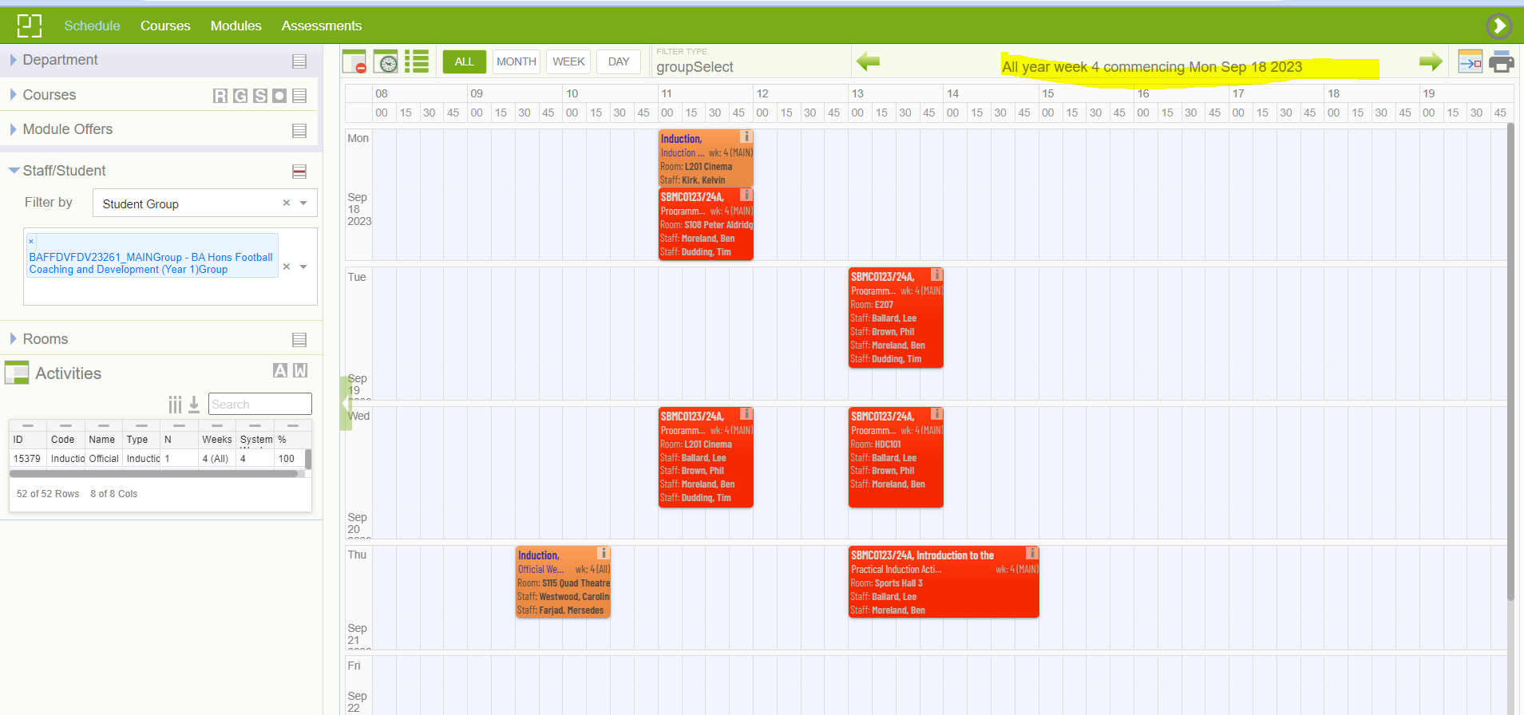

FD/BA Sport Development and Coaching (Induction)
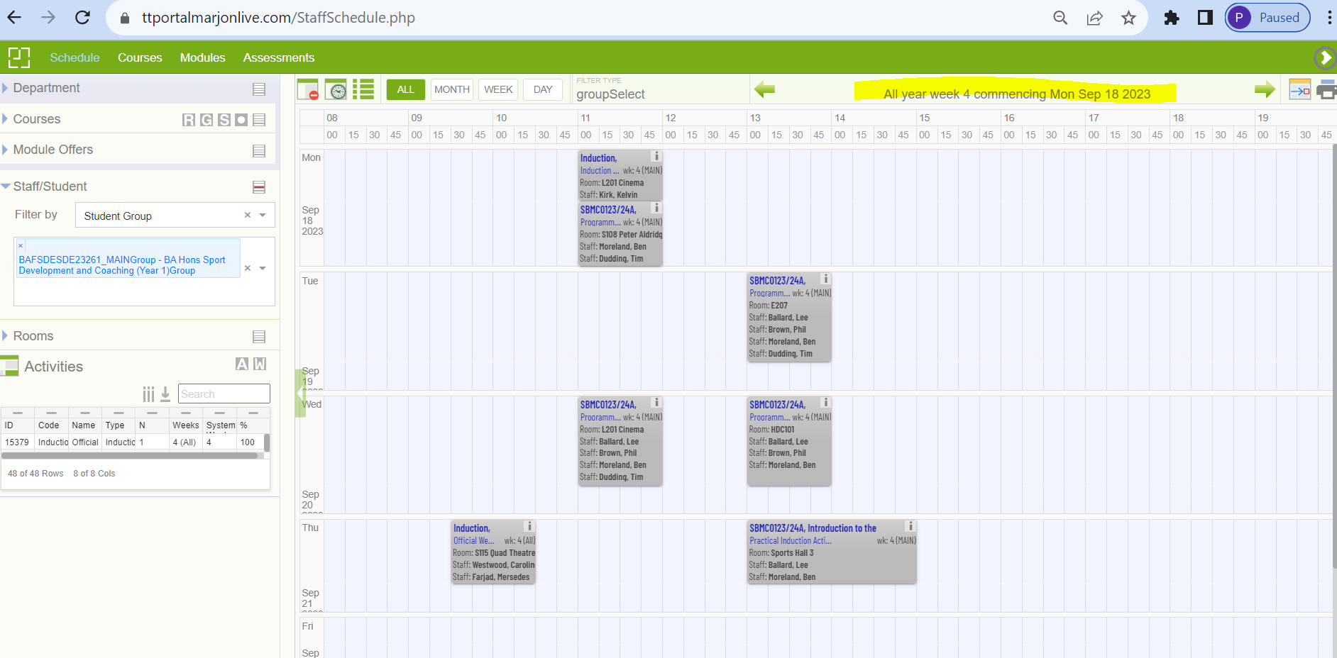

BSc Sport Business Management (Induction)
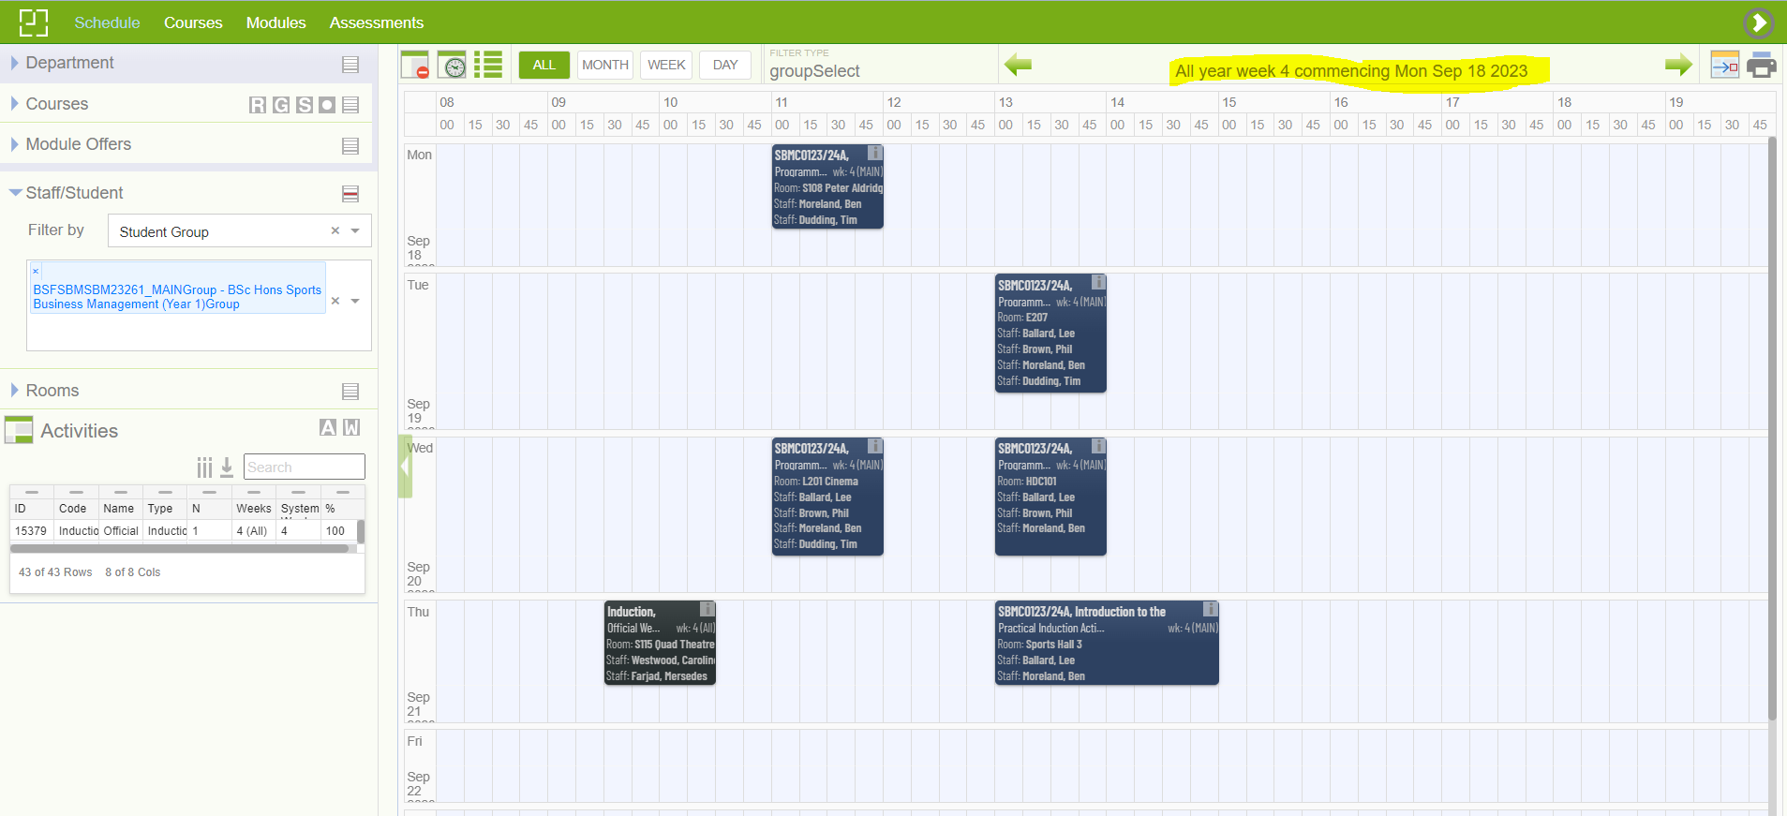

BA Football Coaching and Development – Week 1 teaching timetable
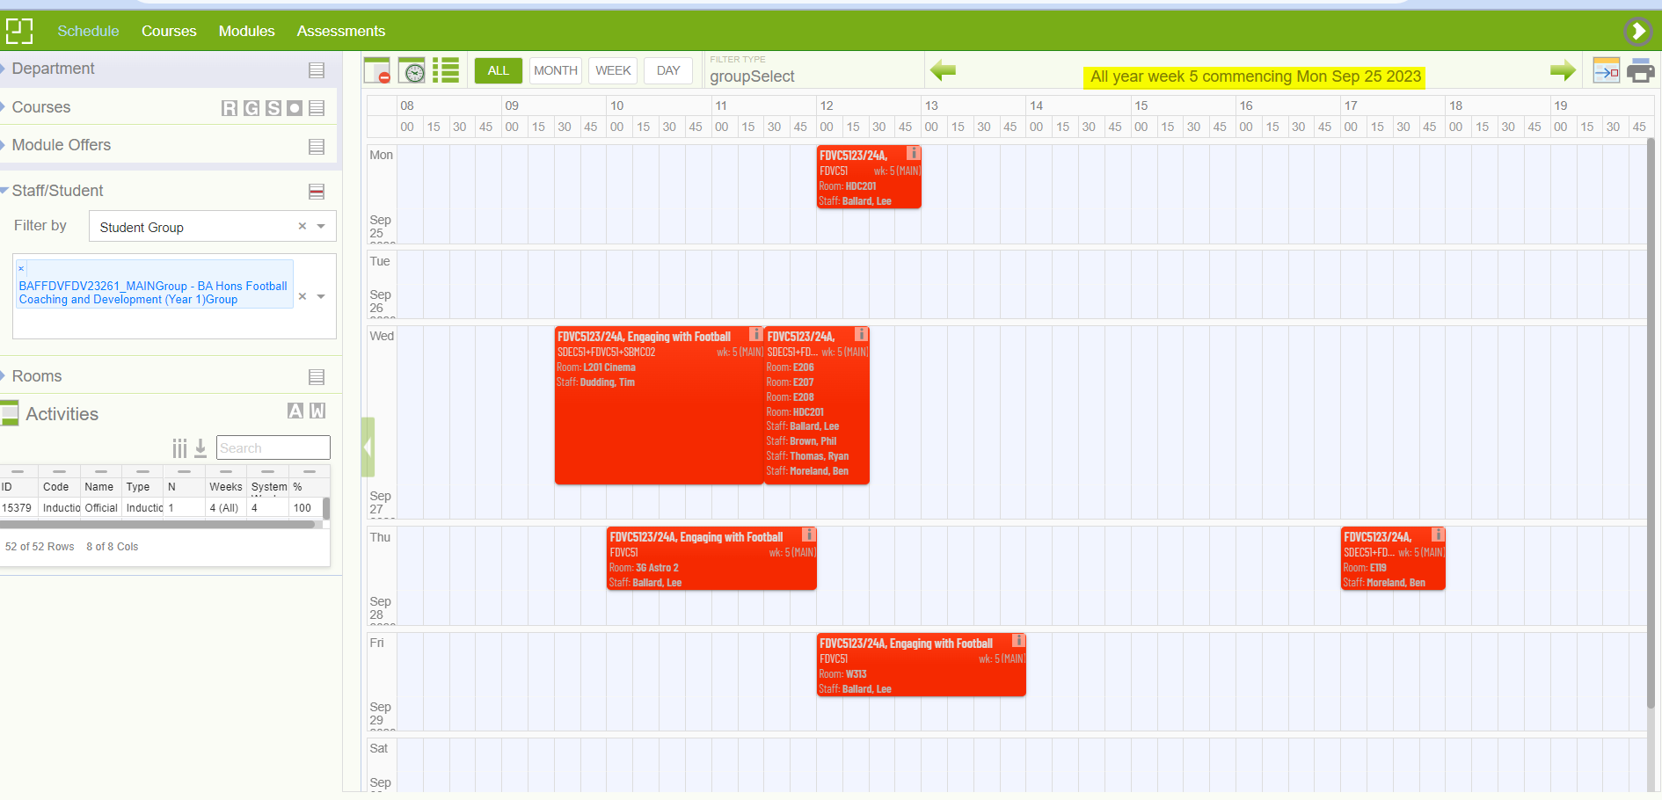

FD/BA Sport Development and Coaching – Week 1 teaching timetable
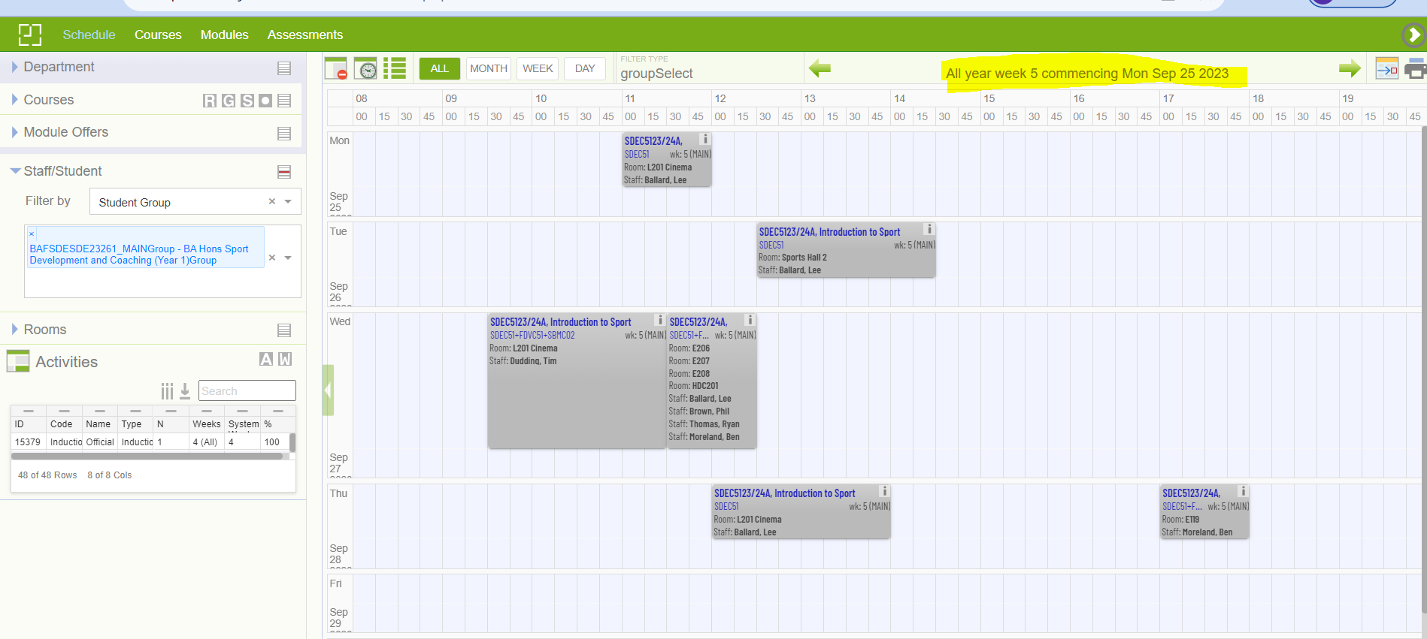

BSc Sport Business Management – Week 1 teaching timetable
