MA Education – part-time – Truro Campus

Pre-enrolment course reading

- Judith Bell and Stephen Waters (2014) Doing your Research Project: a Guide for First Time Researchers. Open University press.

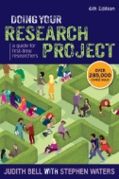

- Denscombe, M. (2017). The Good Research Guide: for small-scale social research projects (6th ed.). Buckingham: Open University Press.
- Kumar, R. (2014). Research Methodology: A step-by-step guide for Beginners. (4th ed.). London: Sage.
- Opie, C. & Brown, D. (2019). Getting Started in your Educational Research. London: Sage

