BA (Hons) Journalism & BA (Hons) Sports Journalism
Part-Time Indicative Timetable

Welcome Week – Week Beginning 19 September 2022

Week Beginning 26 September 2022
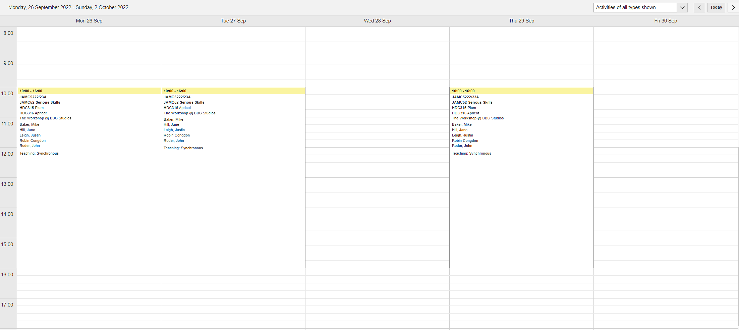

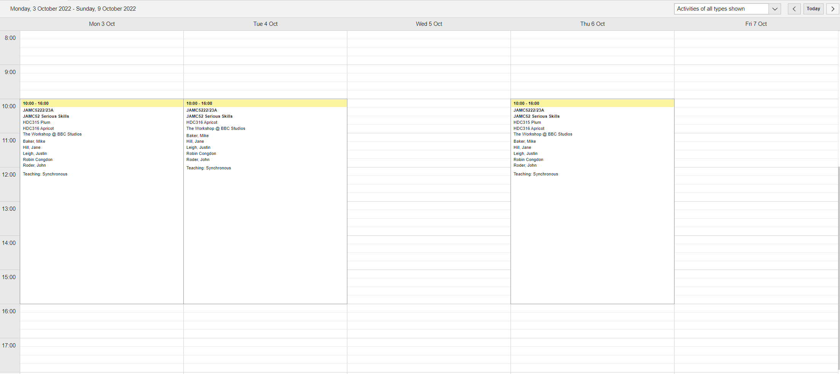
Week Beginning 3 October 2022

Week Beginning 10 October 2022
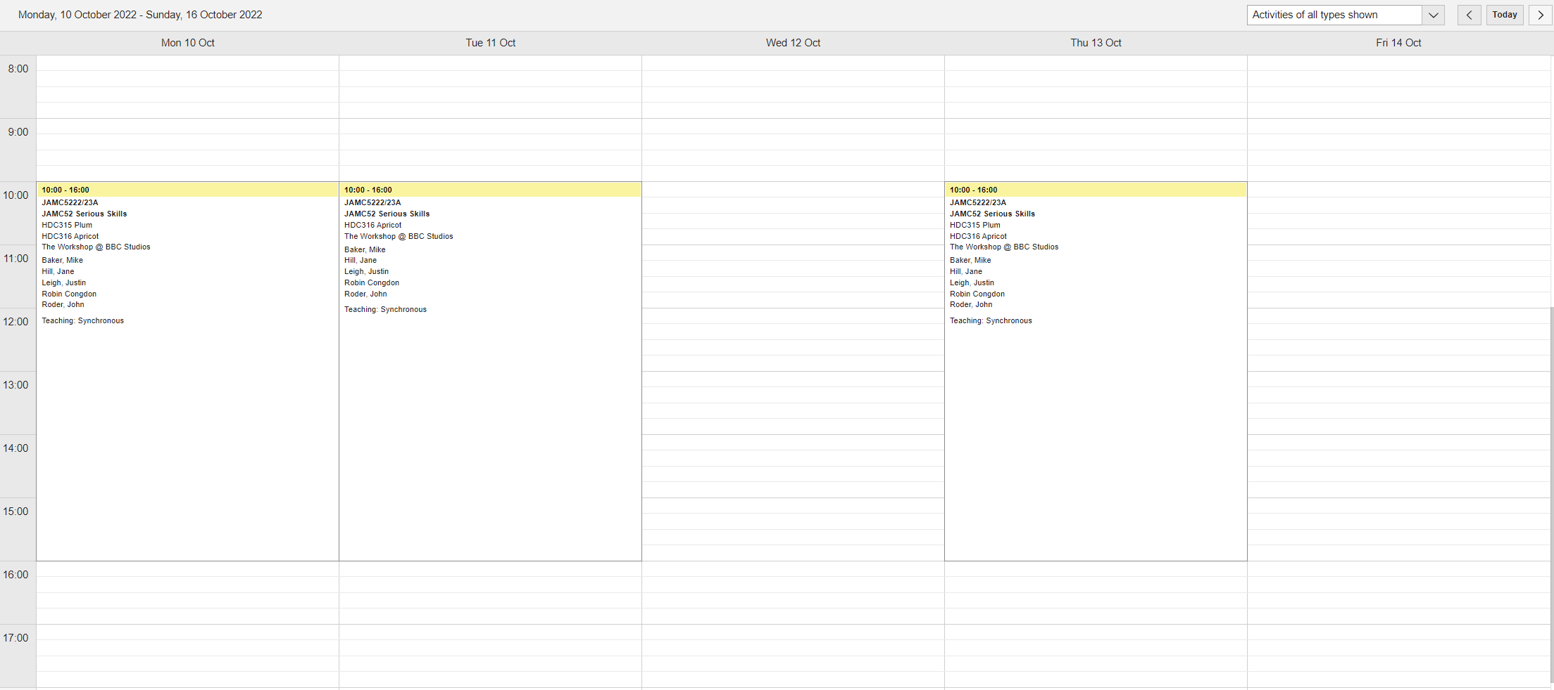

Week Beginning 17 October 2022
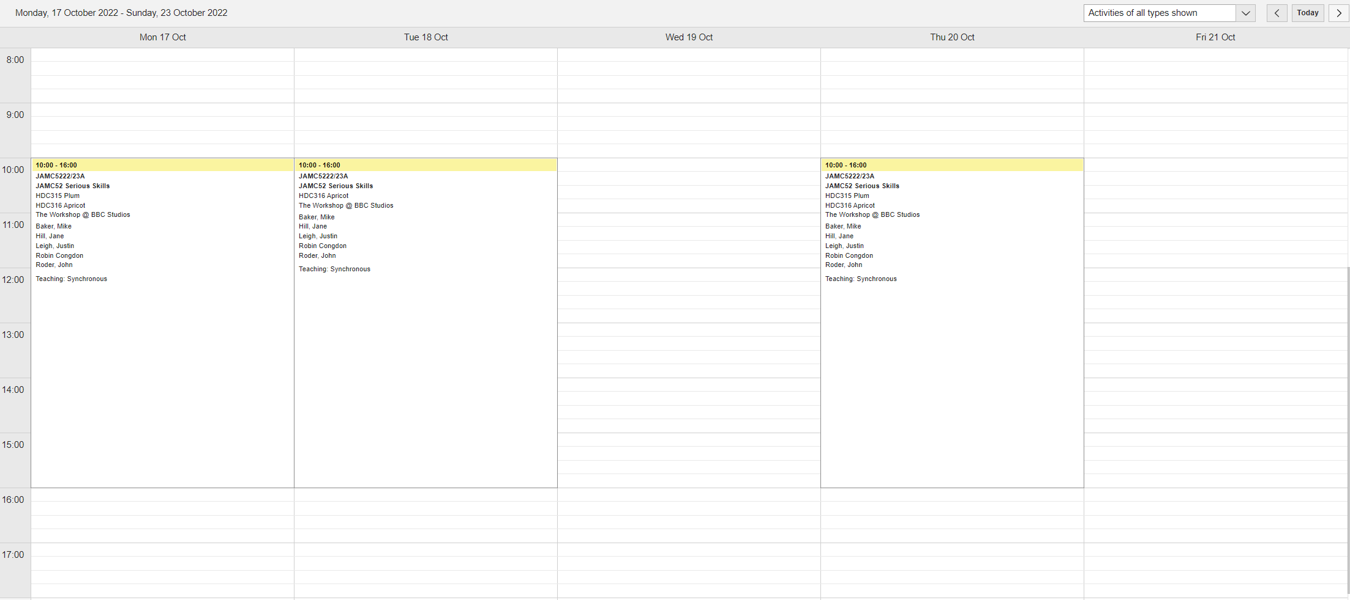

Week Beginning 24 October 2022

This is Reading Week – no teaching

