BA (Hons) Physical Education and BA (Hons) Physical Education with Dance
Year 1 Indicative Timetable for First 5 Weeks
Week beginning 19th September 2022 (week 4)
Monday
1.30 till 10.30am Induction S115 Quad Theatre Introduction to the School or Sport
Tuesday
12 till 1.30pm S107 BA (Hons) Physical Education and BA (Hons) Physical Education with Dance Programme Specific Session
Wednesday
1 till 3pm E203 Chelsea Room BA (Hons) Physical Education and BA (Hons) Physical Education with Dance joining with BA (Hons) Sport Coaching. Meet your Personal Development Tutor (PDT).
Thursday
1 till 2.30pm 3G Astro 1 and 2 Practical Session BA (Hons) Physical Education and BA (Hons) Physical Education with Dance joining with BA (Hons) Sport Coaching.

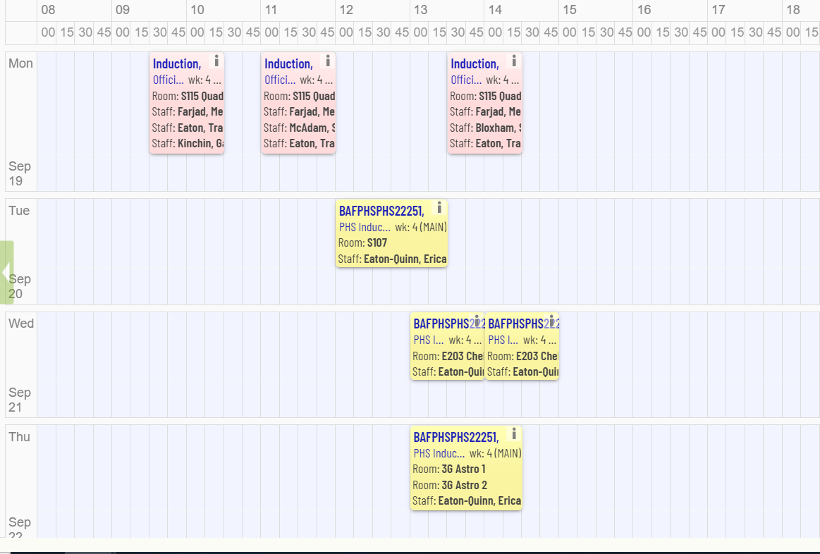

Week beginning 26th September 2022 (week 5)
Monday
2.30 till 4.30pm PHSC03 in E206
Tuesday
9.30 till 11.30am PHSC03 in W304 (Group A)
11.30 till 1.30pm PHSC03 in W304 (Group B)
3 till 5pm PHSC03 in L201 Cinema
Thursday
2 till 4pm PHSC03 E206
Friday
10 till 1pm PHSC03 in E208 (Group A)
1 till 4pm PHSC03 in E208 (Group B)
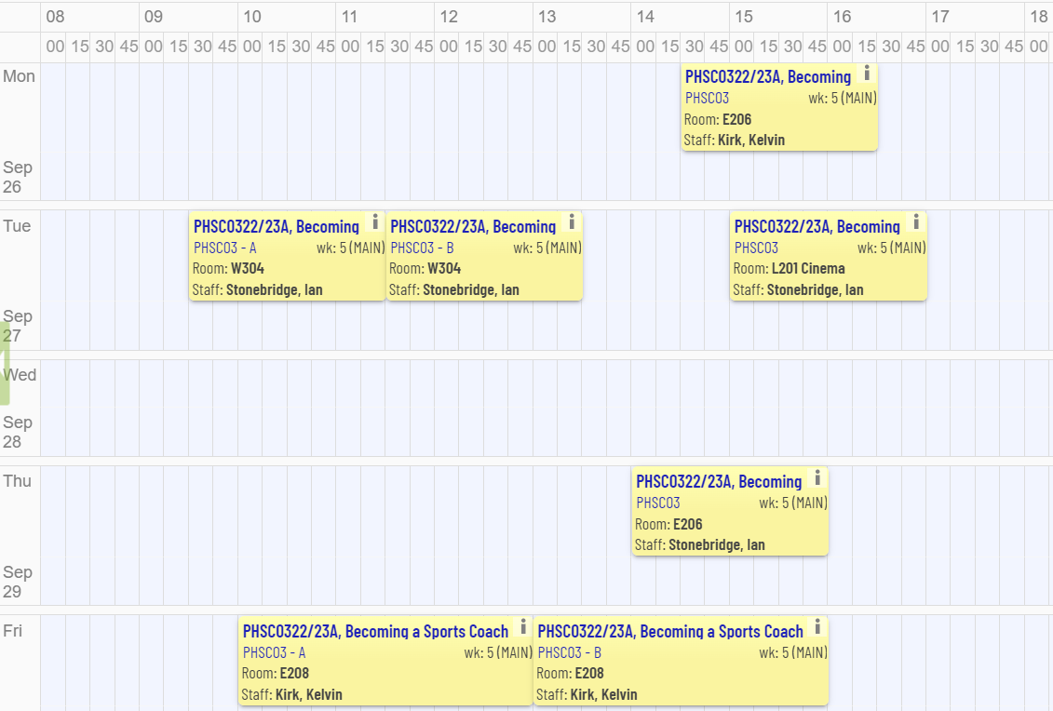

Week beginning 3rd October 2022 (week 6)
Monday
10 till 12 PHSC03 in HDC101
1 till 3pm PHSC03 in L201 Cinema
Tuesday
9 till 11am PSHC03 in Sports Halls 1 and 2
11 till 1pm PHSC03 in W304 (Group A)
4 till 6pm PHSC03 in E119 (Group B)
Thursday
9.30 till 11.30 PHSC03 in E119 (Group A)
11.30 till 1.30pm PHSC03 in E119 (Group B)
Friday
10 till 12 PHSC03 in E208
12 till 2pm PHSC03 in E208
2 till 4pm PHSC03 in E208

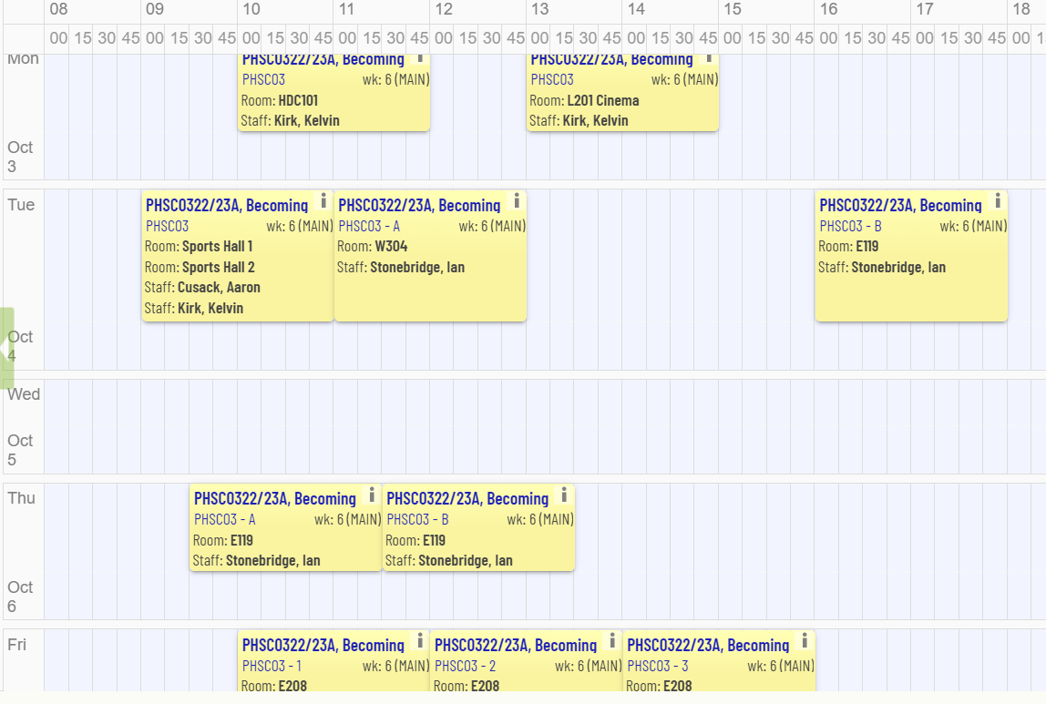
Week beginning 10th October 2022 (week 7)
Monday
9.30 till 11am PHSC03 Online Connected (Group A)
11 till 12.30 PHSC03 Online Connected (Group B)
3 till 5pm PHSC03 in L201 Cinema
Tuesday
1 till 3pm PHSC03 in Sports Halls 2 and 3
3 till 5pm PHSC03 in W304 (Group B)
Thursday
9.30 till 11.30am PHSC03 in HDC101
11.30 till 1.30 PHSC03 in W304 (Group A)
2.30 till 4.30 PHSC03 in W304 (Group B)
Friday
10 till 12 PHSC03 in W304 (Group A)
1 till 3pm PHSC03 in E118

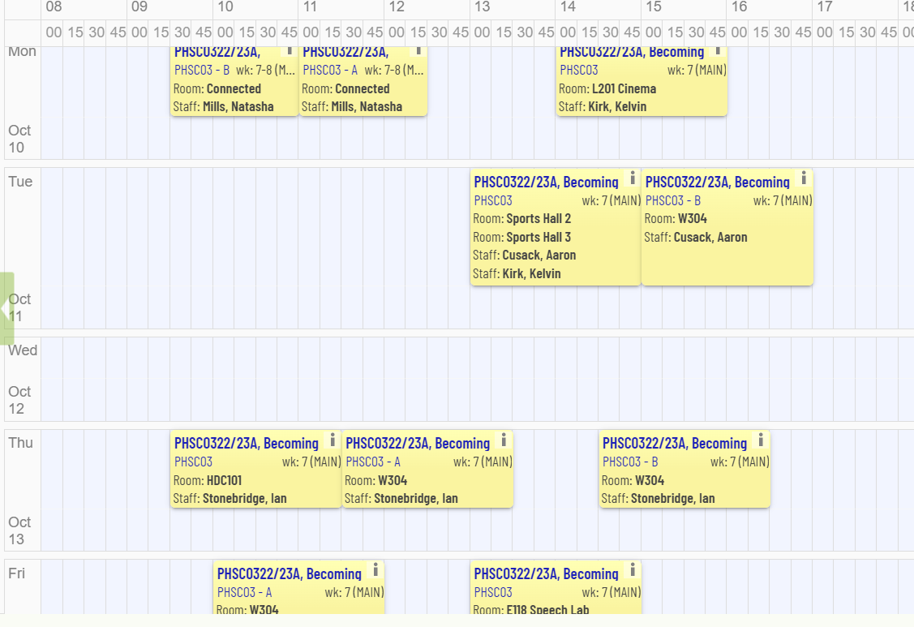
Week beginning 17th October 2022 (week 8)
Monday
9.30 till 11 PHSC03 Online Connected (Group B)
11 till 12.30pm PHSC03 Online Connected (Group A)
2 till 4pm PHSC03 in Sports Halls 2 and 3
Tuesday
9 till 11am PHSC03 in rooms S109 and S110
Thursday
12.30 till 2.30pm PHSC03 in W304 (Group A)
2.30 till 4.30 PHSC03 in W304 (Group B)
Friday
11 till 1pm PHSC03 in rooms E118 and E119

