The core MSc Psychology teaching team:

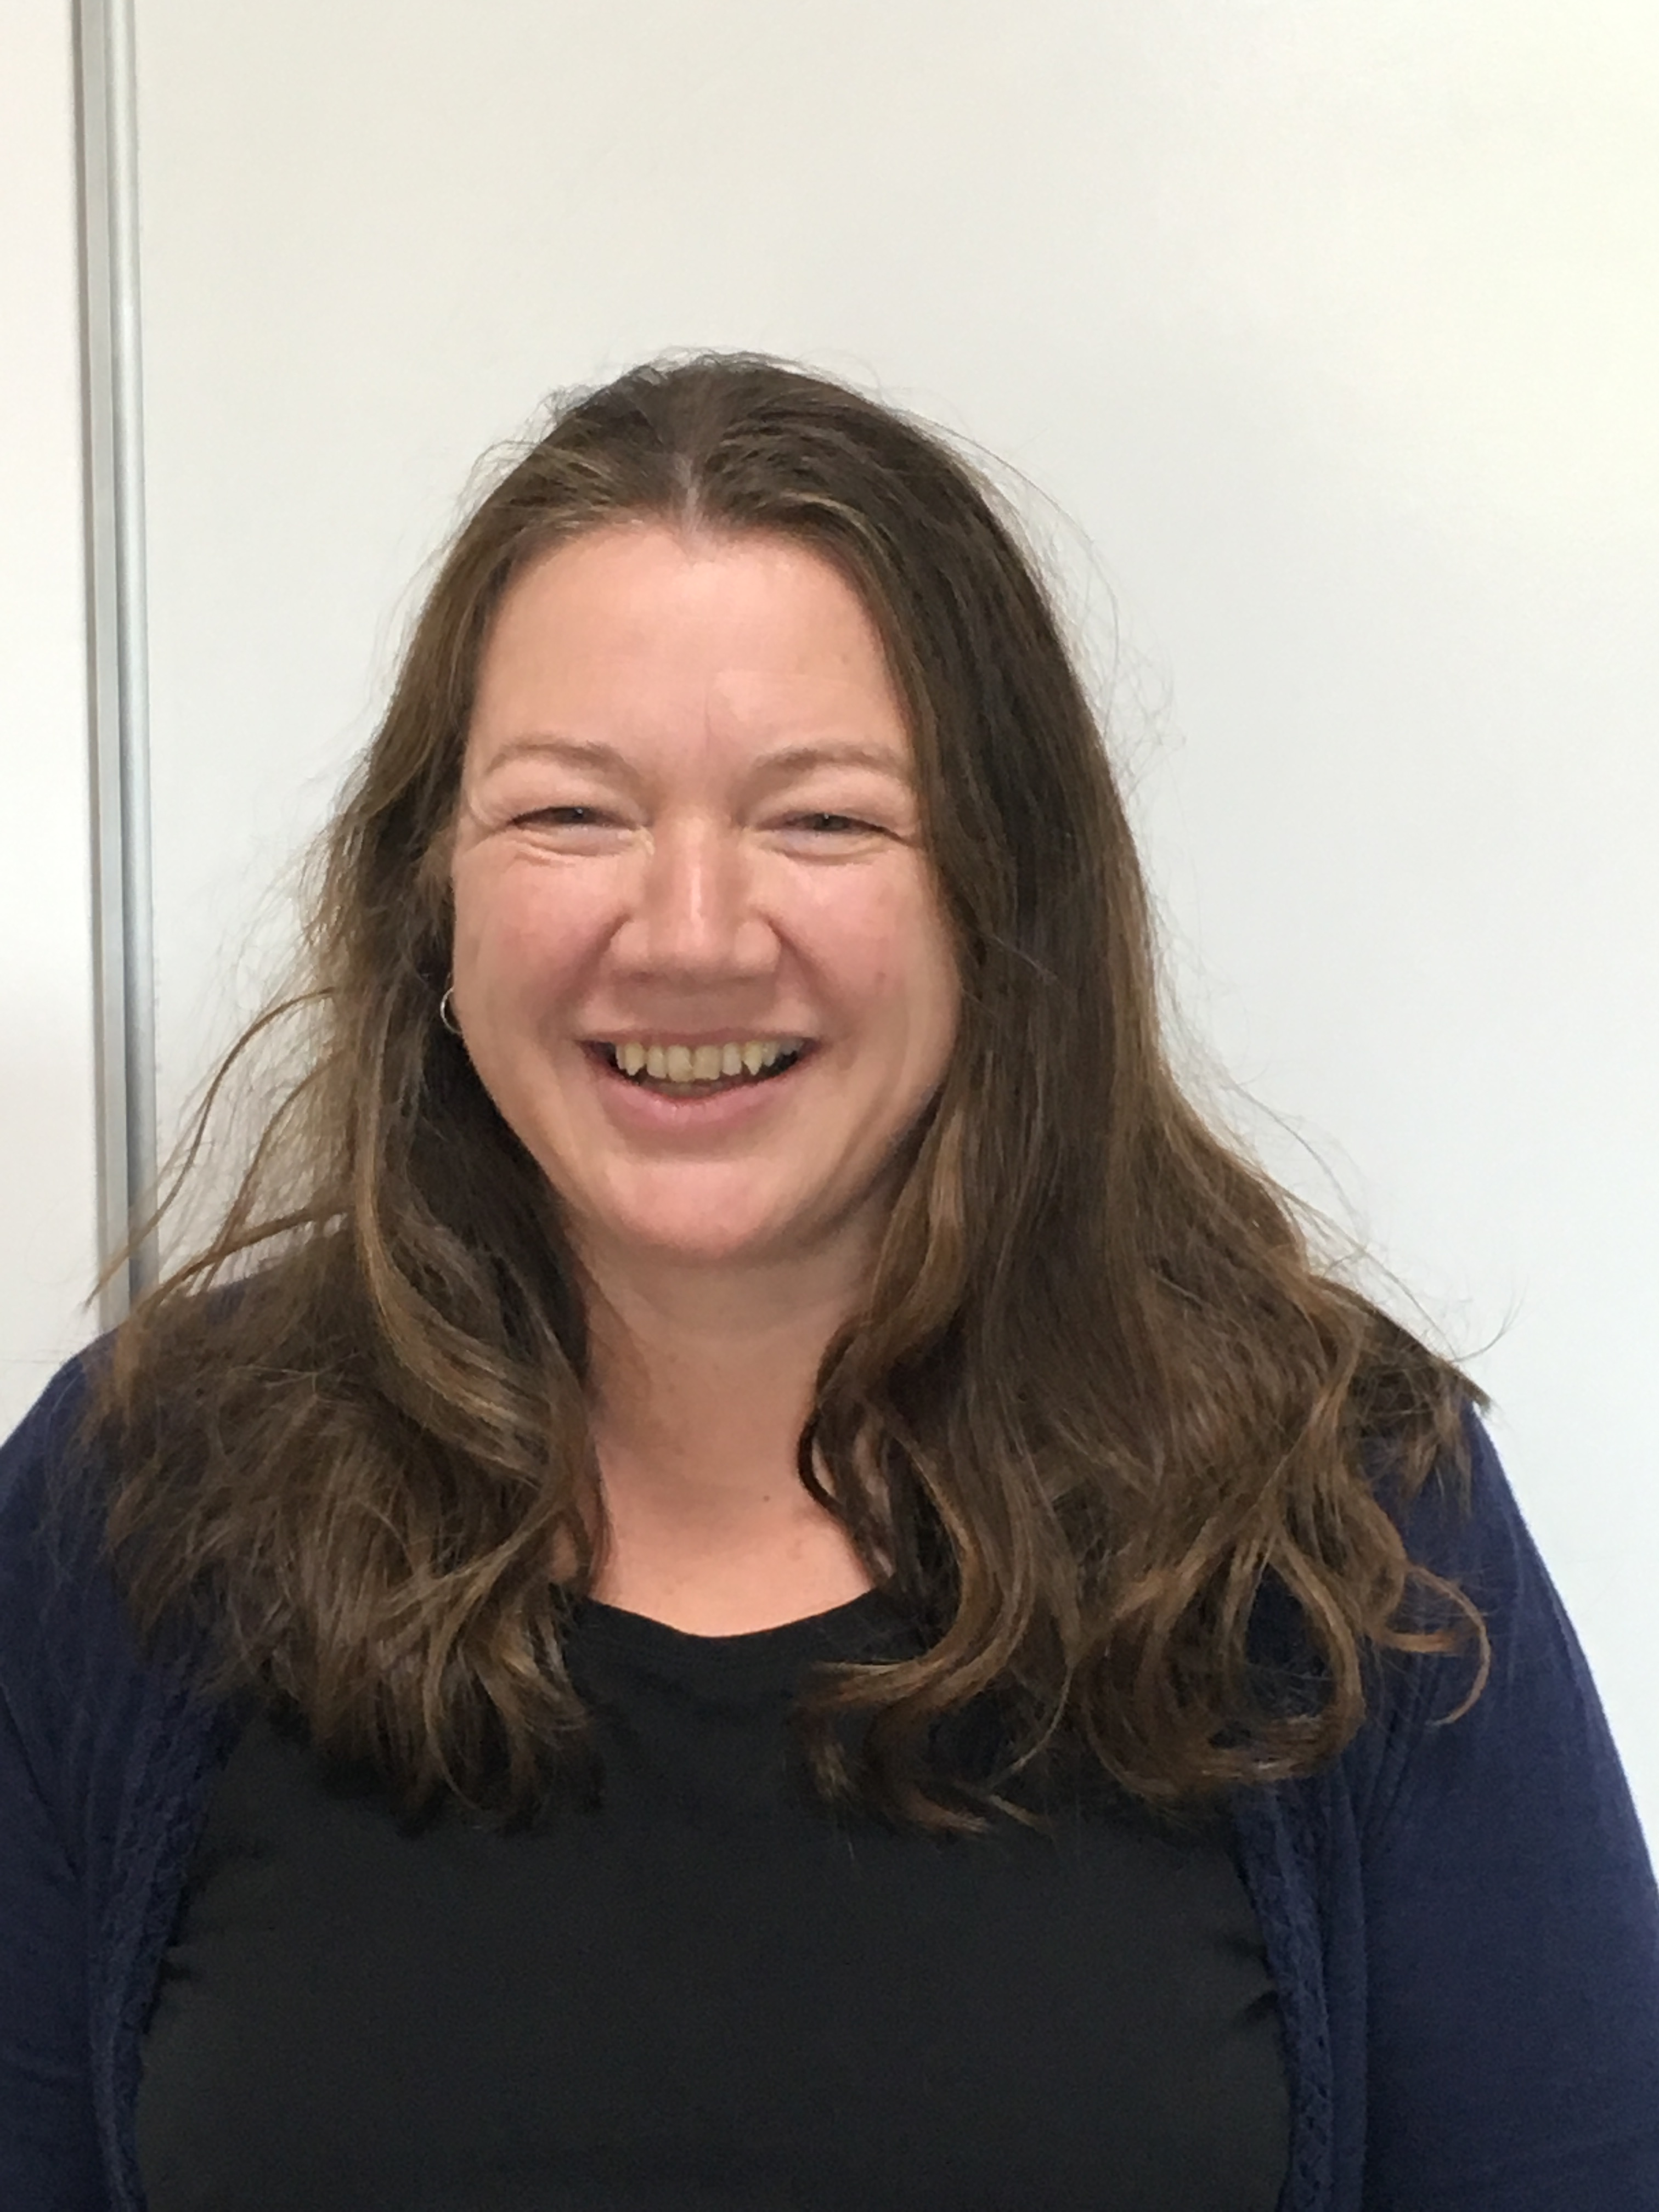 | Dr Hazel Bending is the programme lead for the BSc Psychology and BSc Psychology with Education programmes.  She is a Senior Fellow of the HEA, in addition to being an Associate Fellow and Chartered Member of the British Psychological Society, and a full member of the Division of Academic, teachers and Researchers in Psychology. She sits on the Strategic BPS Members Board and is an external examiner for the MSc Psychology(conversion) at MMU, and for the undergraduate psychology programmes at Wolverhampton University. She has been an invited panel member for AECC Bournemouth validation board. Her research areas include identity, student experience and wellbeing. She has 4 PhD students, and supervises 2 MRES students. See CV for full list.
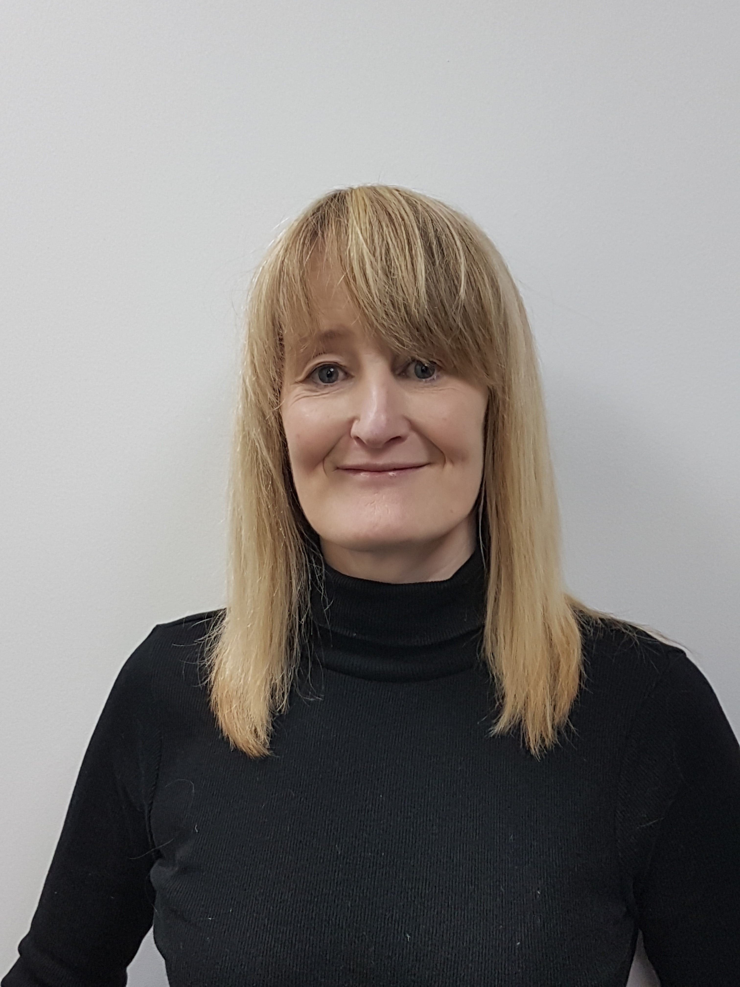 | Dr Katheryn Edwards is working towards Fellowship status of the HEA, and is a Chartered Member of the British Psychological Society. She is also a member of the Society for the Teaching of Psychology (APA division) and has published a number of psychology papers in internationally recognised science journals. Her PhD was an investigation of the dual process account of human mind-reading, during which she maintained an outstanding academic record, winning numerous prizes for excellence. Her research interests include the nature and development of theory of mind and related motor processing. As a recognised expert in this area she was invited to talk at the International Convention of Psychological Science (Paris, 2019) and is a frequent peer-reviewer for the Cognition journal. Katheryn currently supervises 3 PhD students and 1 MRES student. See CV for full list of achievements.
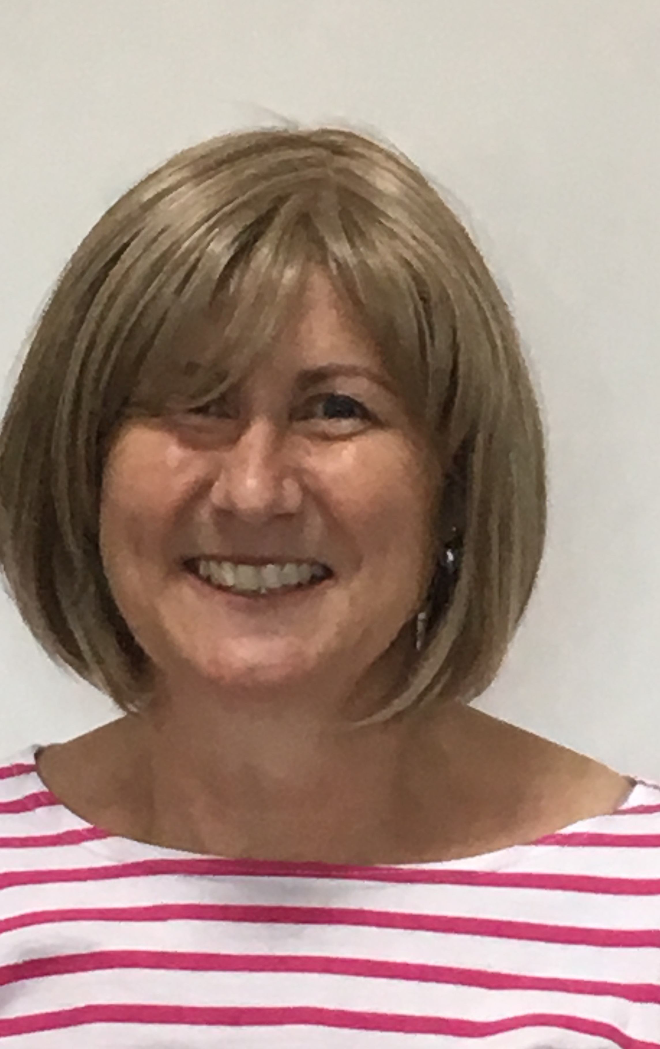 | Tracy Edwards is the psychology technician.  She is a member of the Association of Technical Staff in Psychology and of the Institute of Science & Technology.  She supports undergraduate and postgraduate students in areas such as the application of statistical analysis, writing skills and presentation skills. She has a keen interest in biopsychology, particularly in furthering student understanding of the brain structure and function and runs the laboratory activities including practical brain dissection.  She also supports the running of the Marjon Memory Café.
 | Mrs Carina Robertson is a Fellow of the HEA, and is a Chartered Member of the British Psychological Society. She is a registered clinician with The Health Care Professions Council (HCPC). She has had her own practice for 25 years, and specialises in trauma, PTSD, weight and obesity and adolescent mental health. She is currently working on the Healthy Weight Management research project and her research interests include psychological well-being, obesity and the impacts of trauma.
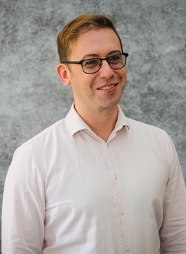 | Dr Jonathan Waddington is working towards associate fellowship status of the HEA and is actively involved in collaborative research projects within the fields of cognitive neuroscience and neuropsychology, focusing on improving outcomes for children and adults with visual or visuocognitive difficulties caused by brain injury. He is passionate about translational research in this field and is currently involved in a project to develop and evaluate gamified perceptual training for children and young people with cerebral vision impairments. He currently supervises 1 MRes student. He has contributed to 14 peer-reviewed publications and 1 book chapter. Outside of academia he works as an advisor at InFocus Charity, a specialist centre that supports young people with vision impairment and complex needs. At InFocus he works within the vision impairment advisory team to train staff working in education, allied healthcare, and paraprofessional roles within the context of specialist education and neurorehabilitation.
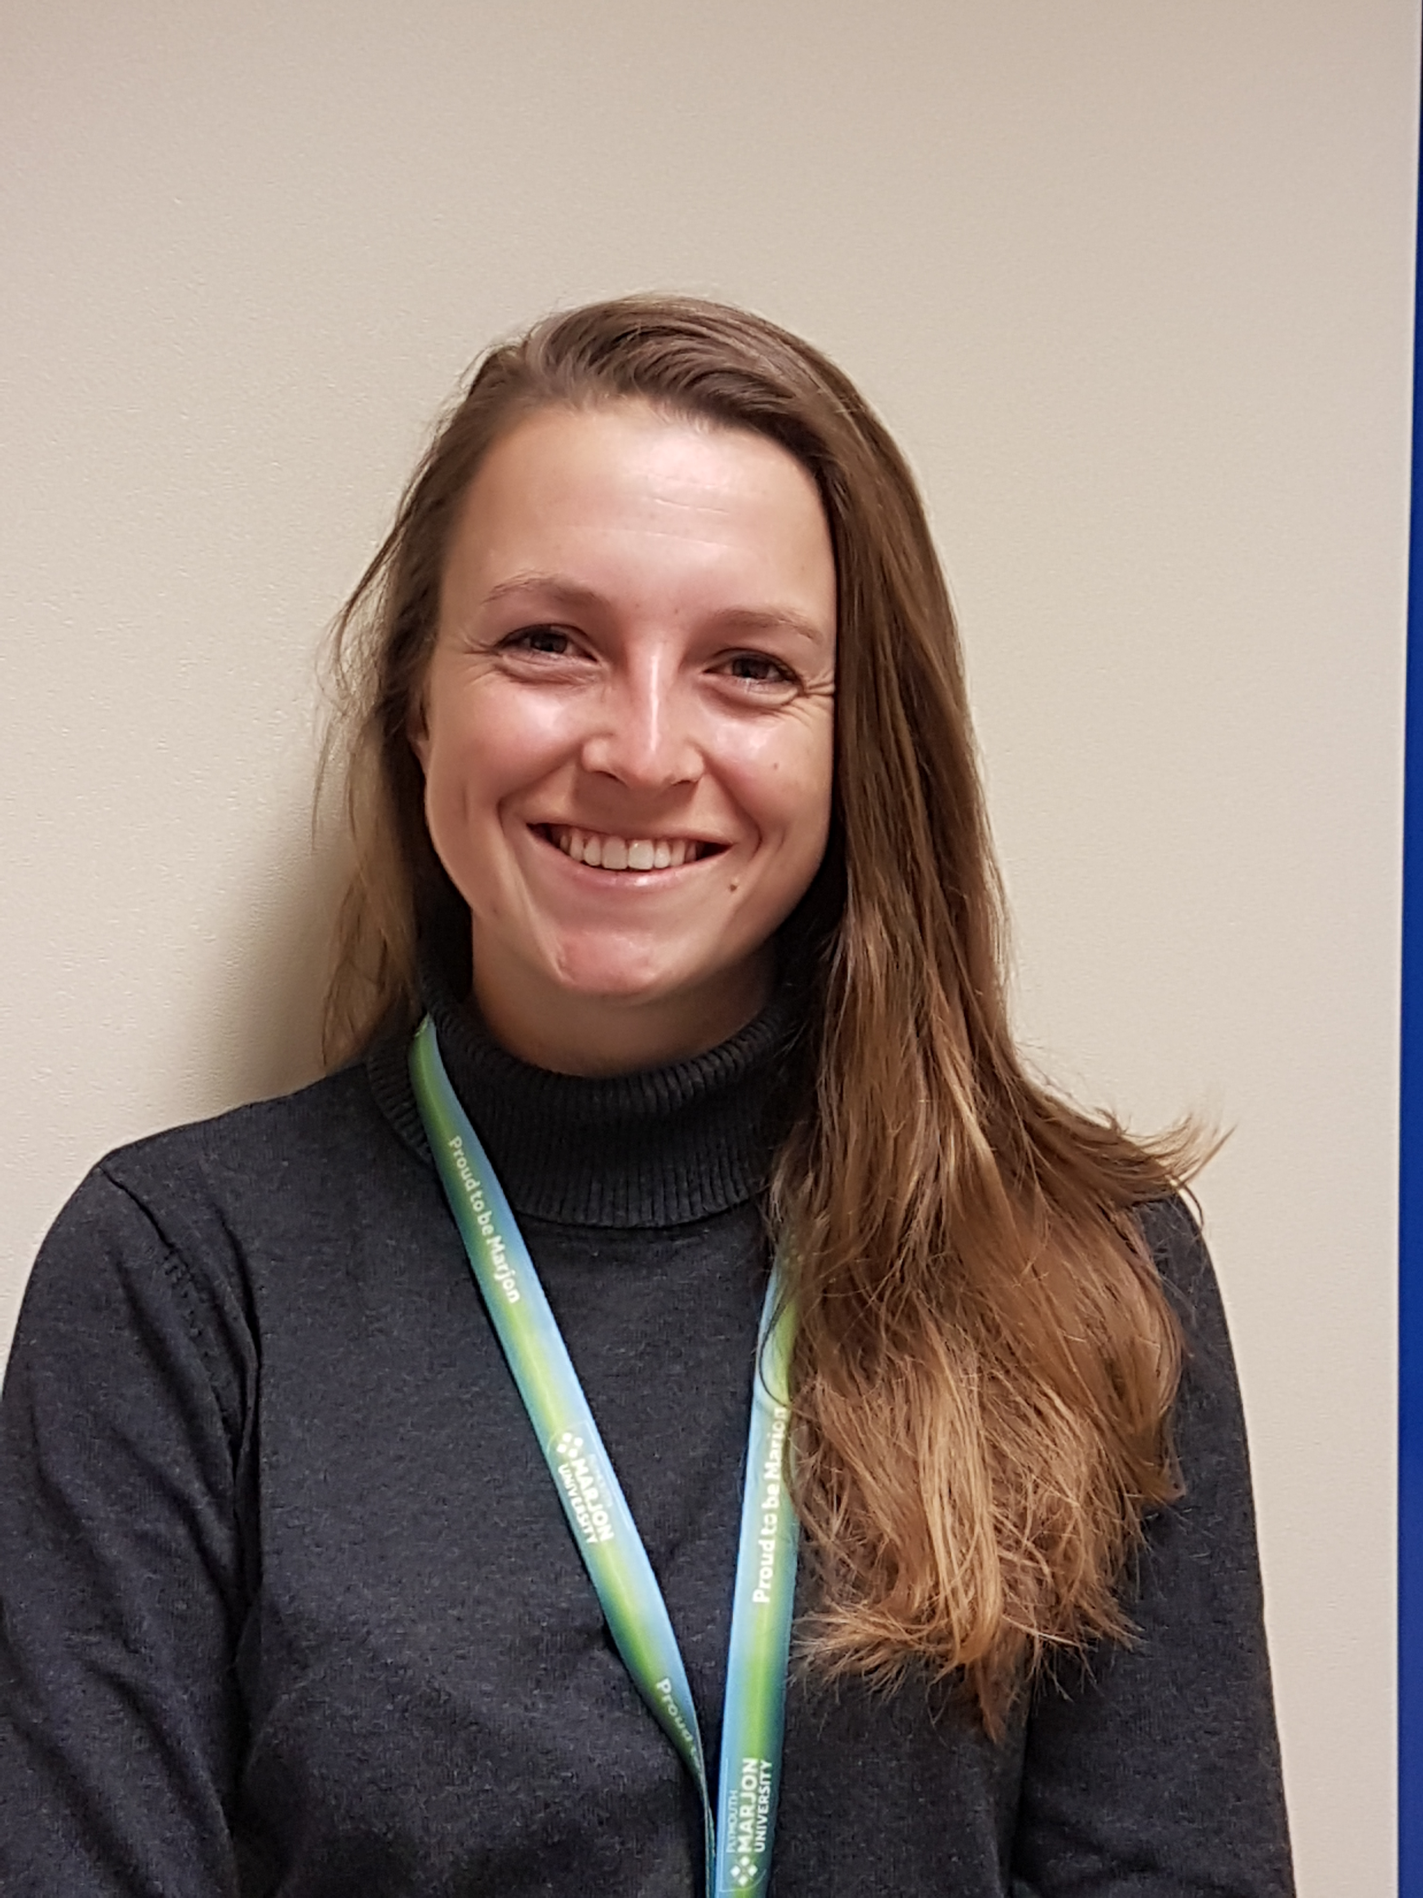 | Dr Rosanna Walters-Symons is the programme lead for the BSc Sport and Exercise Psychology and MRES programmes.  She is a Fellow of the HEA and is a Chartered Member of the British Psychological Society. She is a Senior lecturer in Psychology and programme leader of the MRes. Her PhD was on the topic of visual attention and gaze behaviour in sport. Through the use of eye-tracking technology her thesis tackled some difficult questions surrounding the functional mechanisms that underpin the potential benefits of the Quiet Eye - an objective measure of visuo-motor control.  Her specialist areas sit within cognitive psychology and skill acquisition, primarily in attention, concentration and visuo-motor control.  Her research interests include the perceptual cognitive factors required by sports officials to judge a sports performance and, ultimately, make decisions. Further interests include athlete welfare, high performance environments and the cognitive factors effected by heat stress. Outside of work she is a UKCC level 3 Equestrian coach and mentor and international athlete, having represented Great Britain at six FEI World and European Championships, winning two individual medals and one team medal.

