The core MSc Psychology For Leadership teaching team:

Dr Hazel Bending is the programme lead for the BSc Psychology and BSc Psychology with Education programmes.
She is a Senior Fellow of the HEA, in addition to being an Associate Fellow and Chartered Member of the British Psychological Society, and a full member of the Division of Academic, teachers and Researchers in Psychology. She sits on the Strategic BPS Members Board and is an external examiner for the MSc Psychology(conversion) at MMU, and for the undergraduate psychology programmes at Wolverhampton University. She has been an invited panel member for AECC Bournemouth validation board. Her research areas include identity, student experience and wellbeing. She has 4 PhD students, and supervises 2 MRES students. See CV for full list.
 | Mrs Carina Robertson is a Fellow of the HEA, and is a Chartered Member of the British Psychological Society. She is a registered clinician with The Health Care Professions Council (HCPC). She has had her own practice for 25 years, and specialises in trauma, PTSD, weight and obesity and adolescent mental health. She is currently working on the Healthy Weight Management research project and her research interests include psychological well-being, obesity and the impacts of trauma.
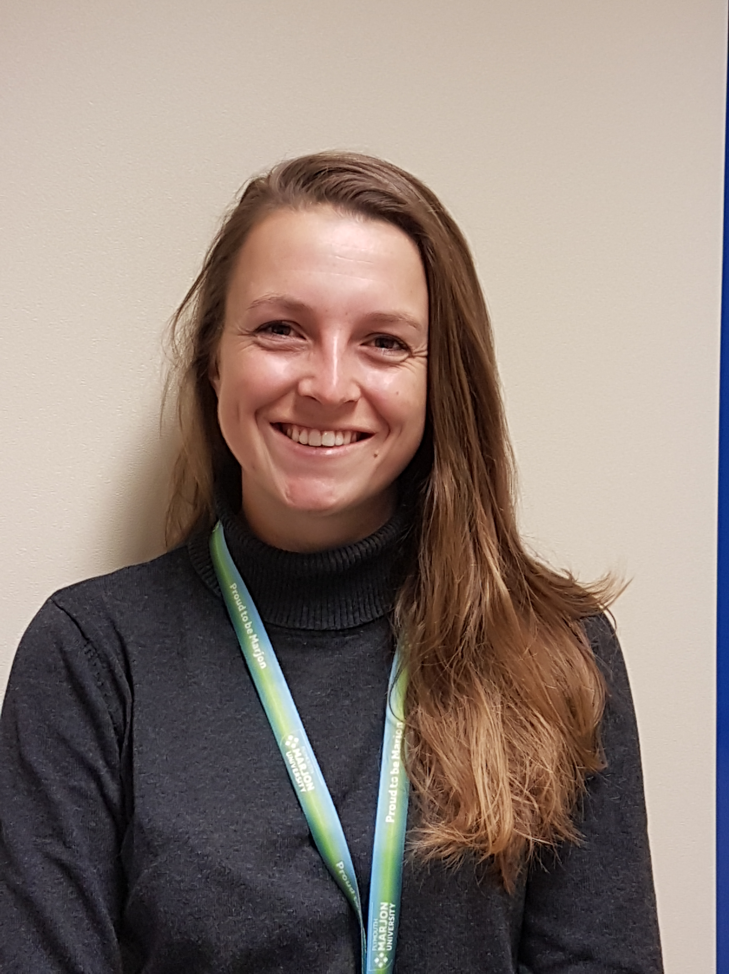 | Dr Rosanna Walters-Symons is the programme lead for the BSc Sport and Exercise Psychology and MRES programmes.  She is a Fellow of the HEA and is a Chartered Member of the British Psychological Society. She is a Senior lecturer in Psychology and programme leader of the MRes. Her PhD was on the topic of visual attention and gaze behaviour in sport. Through the use of eye-tracking technology her thesis tackled some difficult questions surrounding the functional mechanisms that underpin the potential benefits of the Quiet Eye - an objective measure of visuo-motor control.  Her specialist areas sit within cognitive psychology and skill acquisition, primarily in attention, concentration and visuo-motor control.  Her research interests include the perceptual cognitive factors required by sports officials to judge a sports performance and, ultimately, make decisions. Further interests include athlete welfare, high performance environments and the cognitive factors effected by heat stress. Outside of work she is a UKCC level 3 Equestrian coach and mentor and international athlete, having represented Great Britain at six FEI World and European Championships, winning two individual medals and one team medal.

