MA Social Policy
Indicative Timetable

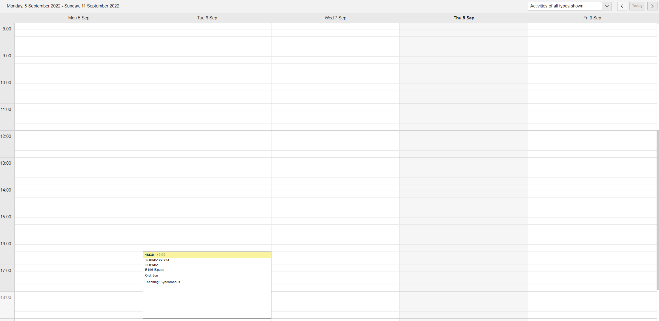
Week Beginning 5 September 2022

Week Beginning 12 September 2022
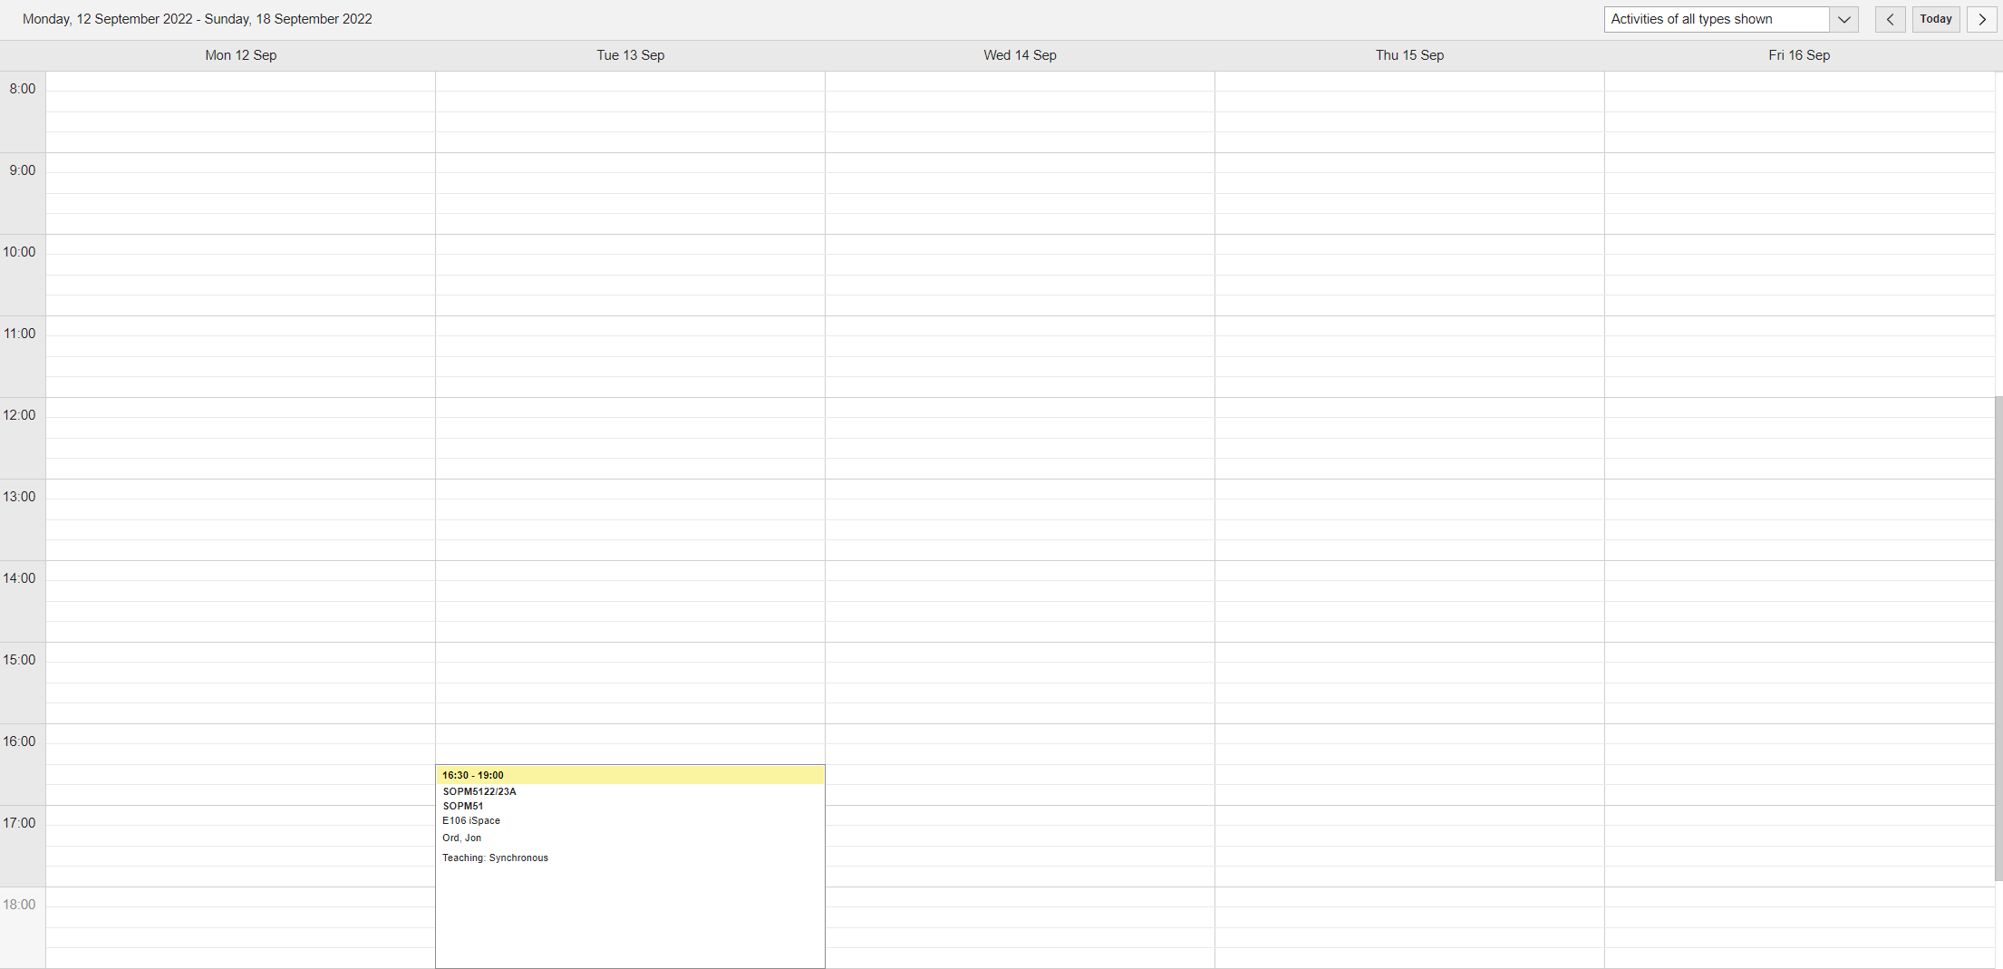

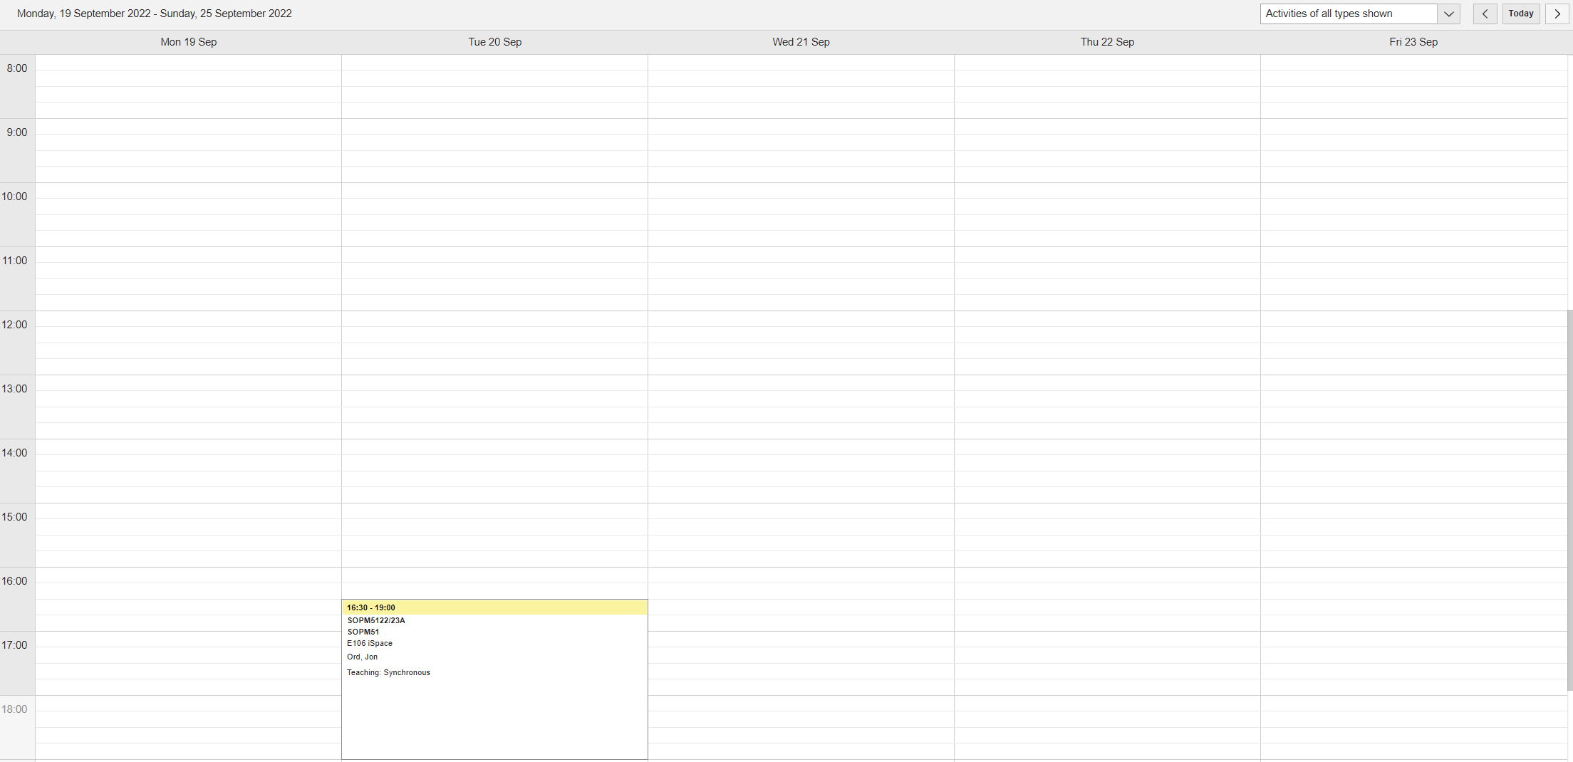
Week Beginning 19 September 2022

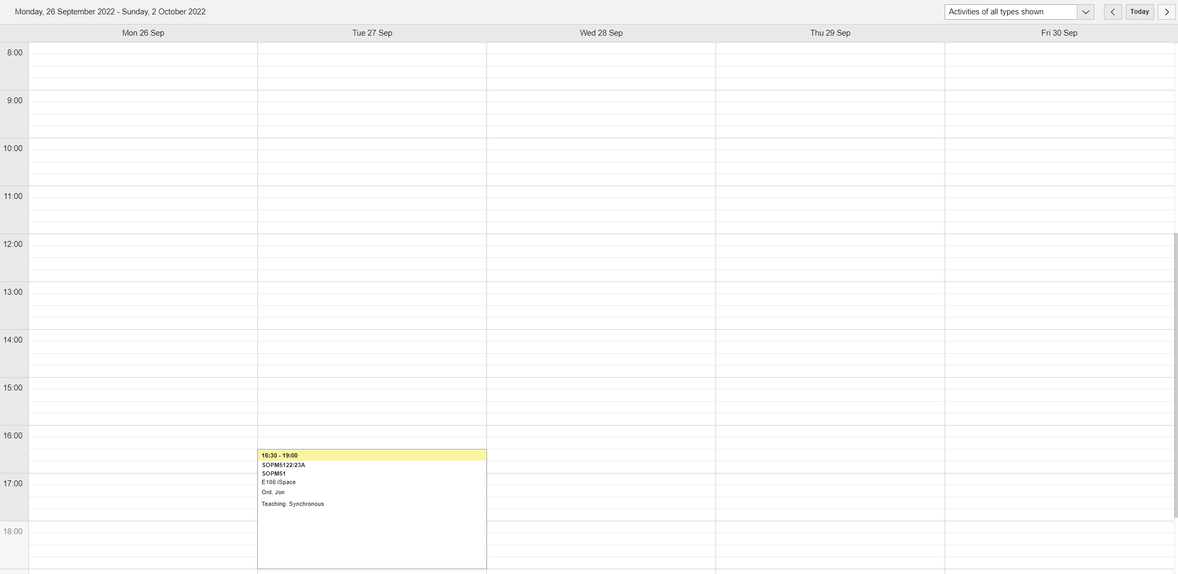
Week Beginning 26 September 2022

Week Beginning 3 October 2022
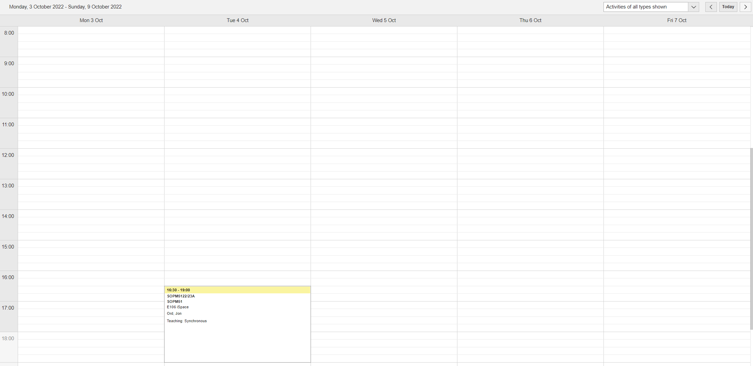

Week Beginning 10 October 2022
