BA (Hons) Special educational Needs and Disability Studies
Indicative Timetable

Welcome Week – Week Beginning 19.09.22
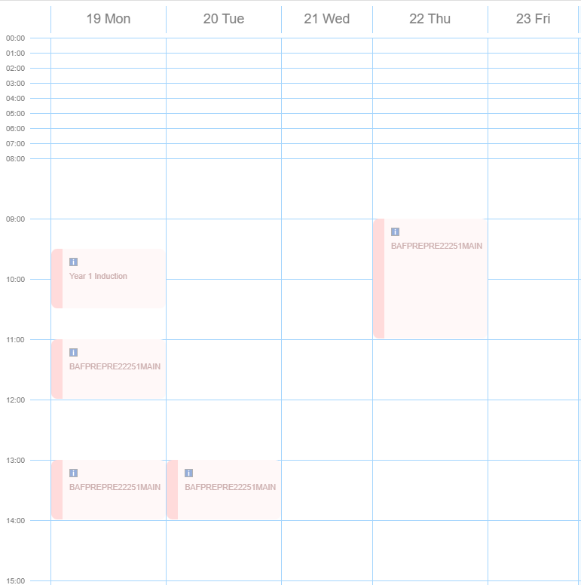

Week Beginning 26.09.22
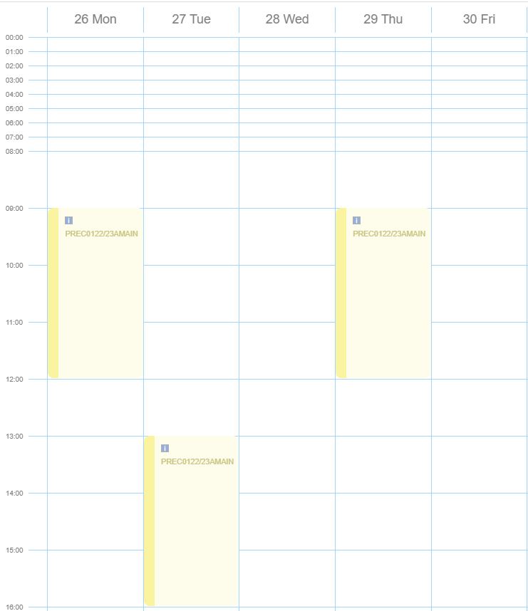

Week Beginning 03.10.22
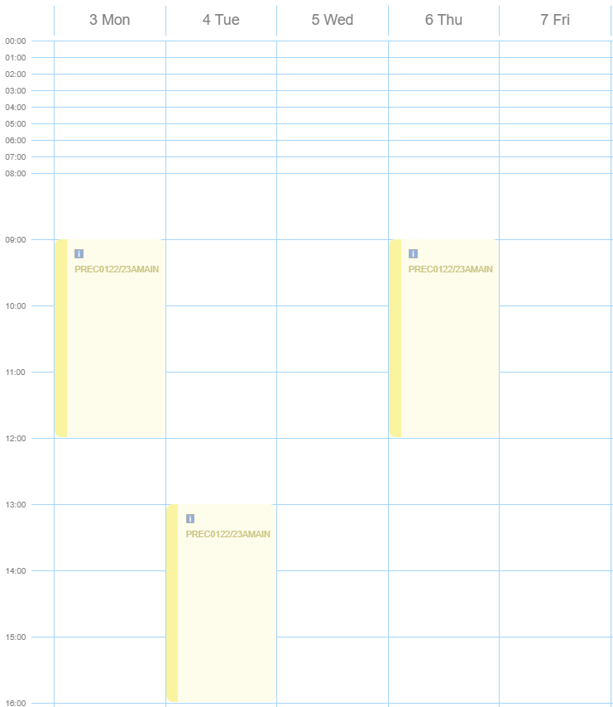

Week Beginning 10.10.22
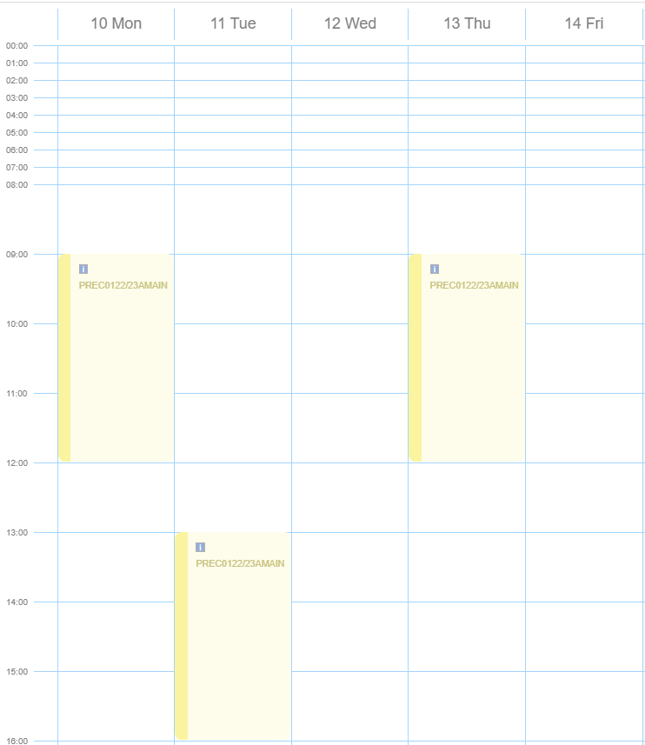

Week Beginning 17.10.22
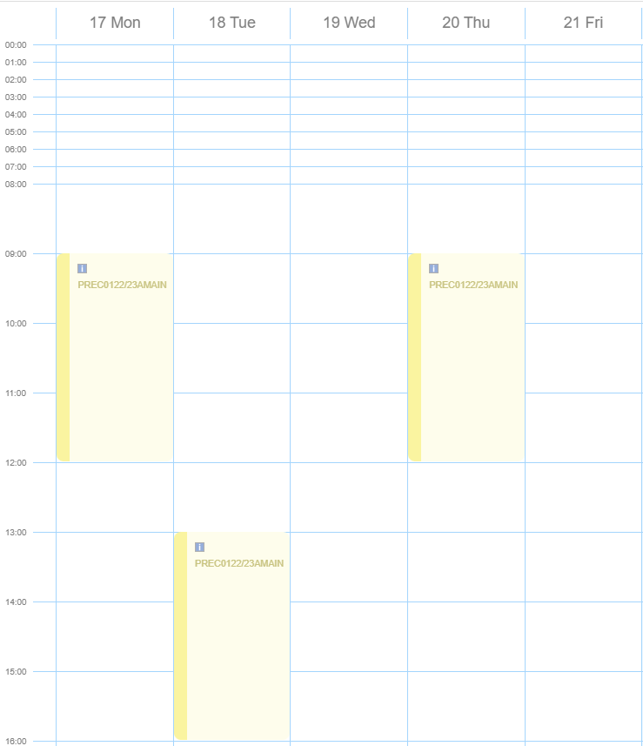

- Week beginning 31.10.22
