The core Sport & Exercise Psychology teaching team:

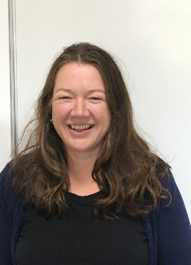 | Dr Hazel Bending is the programme lead for the BSc Psychology and BSc Psychology with Education programmes.  She is a Senior Fellow of the HEA, in addition to being an Associate Fellow and Chartered Member of the British Psychological Society, and a full member of the Division of Academic, teachers and Researchers in Psychology. She sits on the Strategic BPS Members Board and is an external examiner for the MSc Psychology(conversion) at MMU, and for the undergraduate psychology programmes at Wolverhampton University. She has been an invited panel member for AECC Bournemouth validation board. Her research areas include identity, student experience and wellbeing. She has 4 PhD students, and supervises 2 MRES students. See CV for full list.
Melissa Coyle, is the programme lead for the MSc Applied Sport Psychology programme.
She is a senior lecturer at Plymouth Marjon University who is an HCPC registered Sport and Exercise Psychologist and a Fellow of the Higher Education Academy. Melissa has lectured in higher education within the field of sport and exercise psychology since 2004 and has over 17 years’ experience as an applied practitioner, specialising in professional football, swimming, and working with adolescent athletes. She is the external examiner for a postgraduate course in Sport and Exercise Science at Teesside University. Alongside teaching on the undergraduate sport and exercise psychology programme, Melissa is the programme leader for the BPS accredited MSc Applied Sport Psychology programme. Melissa has a number of peer reviewed publications in mental health, and mental health literacy in sport, applied sport psychology in mass participation events, and sharing good practice within the discipline of sport and exercise psychology; and is currently completing her PhD on the topic of mental health in applied sport psychology practice. . Melissa is also a BASES SEPAR supervisor and reviewer, Chartered Scientist, BASES accredited, and also a BASES supervisor and reviewer.

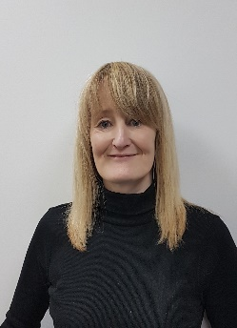 | Dr Katheryn Edwards is working towards Fellowship status of the HEA, and is a Chartered Member of the British Psychological Society. She is also a member of the Society for the Teaching of Psychology (APA division) and has published a number of psychology papers in internationally recognised science journals. Her PhD was an investigation of the dual process account of human mind-reading, during which she maintained an outstanding academic record, winning numerous prizes for excellence. Her research interests include the nature and development of theory of mind and related motor processing. As a recognised expert in this area she was invited to talk at the International Convention of Psychological Science (Paris, 2019) and is a frequent peer-reviewer for the Cognition journal. Katheryn currently supervises 3 PhD students and 1 MRES student. See CV for full list of achievements.
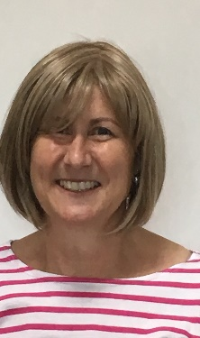 | Tracy Edwards is the psychology technician.  She is a member of the Association of Technical Staff in Psychology and of the Institute of Science & Technology.  She supports undergraduate and postgraduate students in areas such as the application of statistical analysis, writing skills and presentation skills. She has a keen interest in biopsychology, particularly in furthering student understanding of the brain structure and function and runs the laboratory activities including practical brain dissection.  She also supports the running of the Marjon Memory Café.
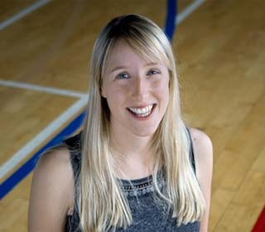 | Miss. Sophie Gibbs-Nicholls is a Fellow of the HEA, and is a Chartered Member of the British Psychological Society as a Sport and Exercise Psychologist. She is registered with the Health and Care Professions Council (HCPC). Sophie currently works with amateur through to elite athletes across a range of sports; including basketball, swimming, surfing, gymnastics and fencing. She has a particular interest in working with university student-athletes to support their wellbeing and performance. She is currently a member of the Performance Services for the FA Women’s High Performance Football Centre and co-leads the Marjon Psyching Team. She has published work on the use of verbal encouragement at mass participation endurance events, and sharing good practice in sport and exercise psychology. She also has a paper under review exploring the sports participation experiences of transgender athletes. Outside of academia she is an International level Pool player, having played for the England Women’s Team for the previous seven years and attended both World and European Championship events.
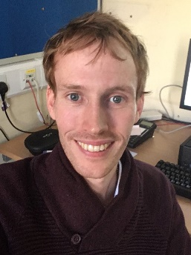 | Dr Alister McCormick is a registered Sport and Exercise Psychologist and a Senior Fellow of Advance HE. His specialist areas are endurance exercise and endurance sports. His research interests include performance enhancement in endurance sports, self-talk interventions, motivation, and interventions for maintaining aerobic exercise. He supervises six PhD students at Marjon, and he leads the provision of psychotherapy and counselling degrees.
 | Mrs Carina Robertson is a Fellow of the HEA, and is a Chartered Member of the British Psychological Society. She is a registered clinician with The Health Care Professions Council (HCPC). She has had her own practice for 25 years, and specialises in trauma, PTSD, weight and obesity and adolescent mental health. She is currently working on the Healthy Weight Management research project and her research interests include psychological well-being, obesity and the impacts of trauma.
 | Dr Jonathan Waddington is working towards associate fellowship status of the HEA and is actively involved in collaborative research projects within the fields of cognitive neuroscience and neuropsychology, focusing on improving outcomes for children and adults with visual or visuocognitive difficulties caused by brain injury. He is passionate about translational research in this field and is currently involved in a project to develop and evaluate gamified perceptual training for children and young people with cerebral vision impairments. He currently supervises 1 MRes student. He has contributed to 14 peer-reviewed publications and 1 book chapter. Outside of academia he works as an advisor at InFocus Charity, a specialist centre that supports young people with vision impairment and complex needs. At InFocus he works within the vision impairment advisory team to train staff working in education, allied healthcare, and paraprofessional roles within the context of specialist education and neurorehabilitation.
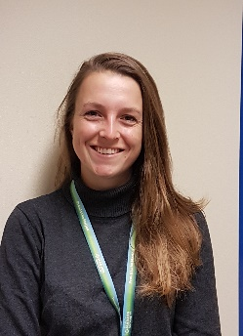 | Dr Rosanna Walters-Symons is the programme lead for the BSc Sport and Exercise Psychology and MRES programmes.  She is a Fellow of the HEA and is a Chartered Member of the British Psychological Society. She is a Senior lecturer in Psychology and programme leader of the MRes. Her PhD was on the topic of visual attention and gaze behaviour in sport. Through the use of eye-tracking technology her thesis tackled some difficult questions surrounding the functional mechanisms that underpin the potential benefits of the Quiet Eye - an objective measure of visuo-motor control.  Her specialist areas sit within cognitive psychology and skill acquisition, primarily in attention, concentration and visuo-motor control.  Her research interests include the perceptual cognitive factors required by sports officials to judge a sports performance and, ultimately, make decisions. Further interests include athlete welfare, high performance environments and the cognitive factors effected by heat stress. Outside of work she is a UKCC level 3 Equestrian coach and mentor and international athlete, having represented Great Britain at six FEI World and European Championships, winning two individual medals and one team medal.

