FD and BA Sport Development and Coaching
Indicative Timetable

Teaching Week 1: Week Beginning 25th September 2023 – note the first four weeks are the Immersive Module. The remaining two modules commence after Study week and will create a different weekly timetable (see below).
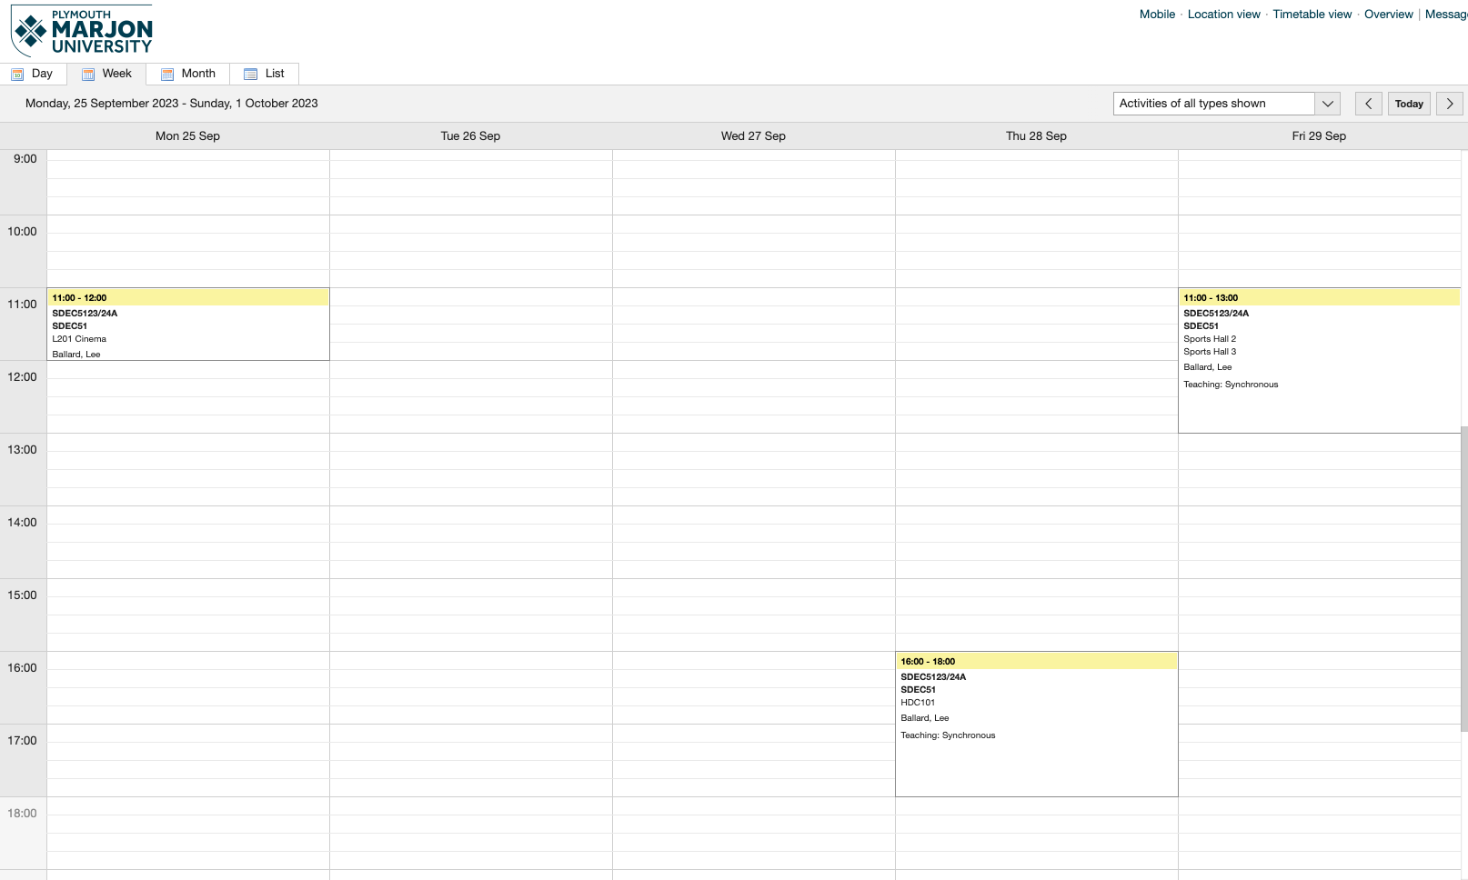

Teaching Week 2: Week Beginning 2nd October

Teaching Week 3: Week Beginning 9th October
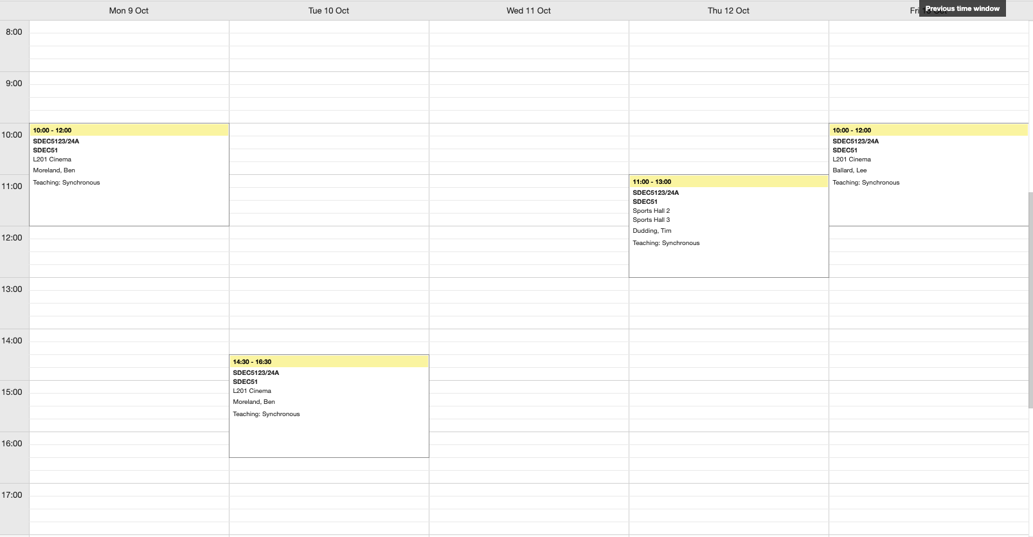

Teaching Week 4: Week Beginning 16th October
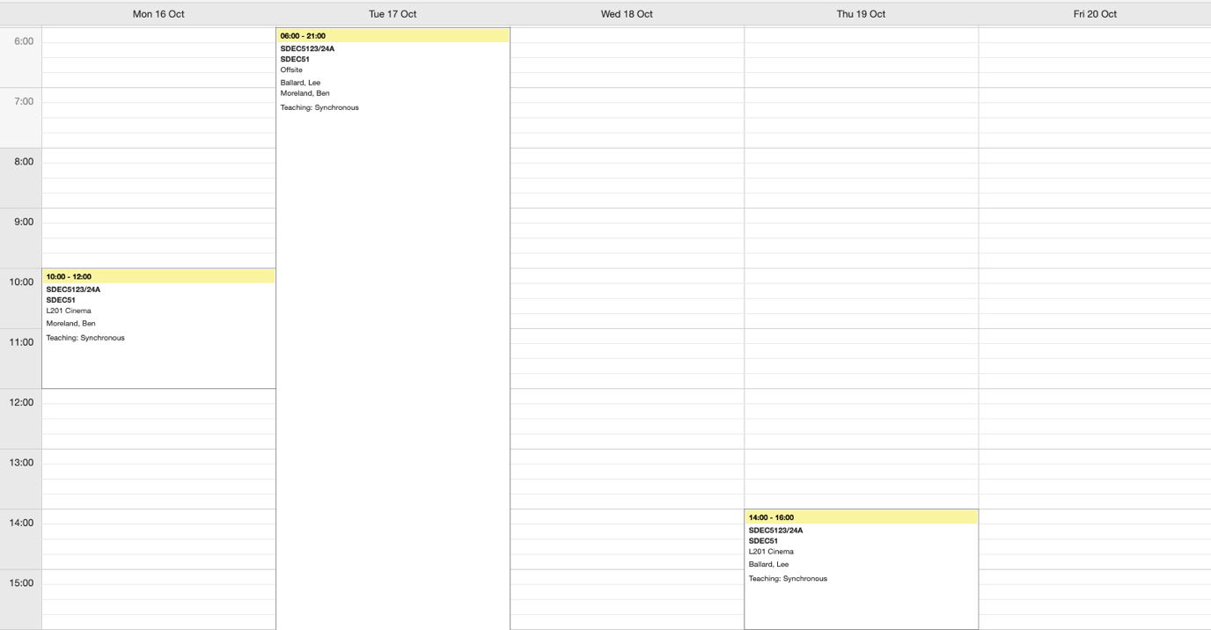

Week 5: Week Beginning 23rd October
Reading/Study week – no scheduled teaching activity

