Module EDCM01 is led by Professor Jennie Winter and is supported by Professor Gillian Golder and Dr Lynne Wyness.

Jennie is Professor of Academic Development, is a National Teaching Fellow and holds Principal Fellowship of Advance HE. Jennie has a range of pedagogic research interests including Education for Sustainable Development, teaching evaluation and student voice, and experimental pedagogies.
You can find out more about Jennie’s work here
and contact her on jwinter@marjon.ac.uk.
Jennie is the module lead for EDCM01.

Gill is Professor in Teacher Education, she has extensive experience in initial teacher education and teacher development. She holds Fellowship of Advance HE. Her underpinning philosophy is of inclusive education showing strong professional values that respect individual learners and diverse learning communities. She has made an outstanding contribution to consultancy and external body work focusing on curriculum design and the synergy between policy practice and research.  Gill is a tutor on EDCM01. | 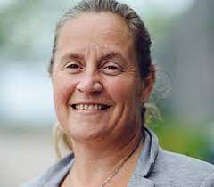
Lynne is a Senior Lecturer and Programme Leader for the first fully distance-learning Masters programme in Professional Education Practice. She advises on digital pedagogy across the university and works with new academics in developing their teaching practice. She holds Senior Fellowship of Advance HE.  Lynne is a tutor on EDCM01. | 